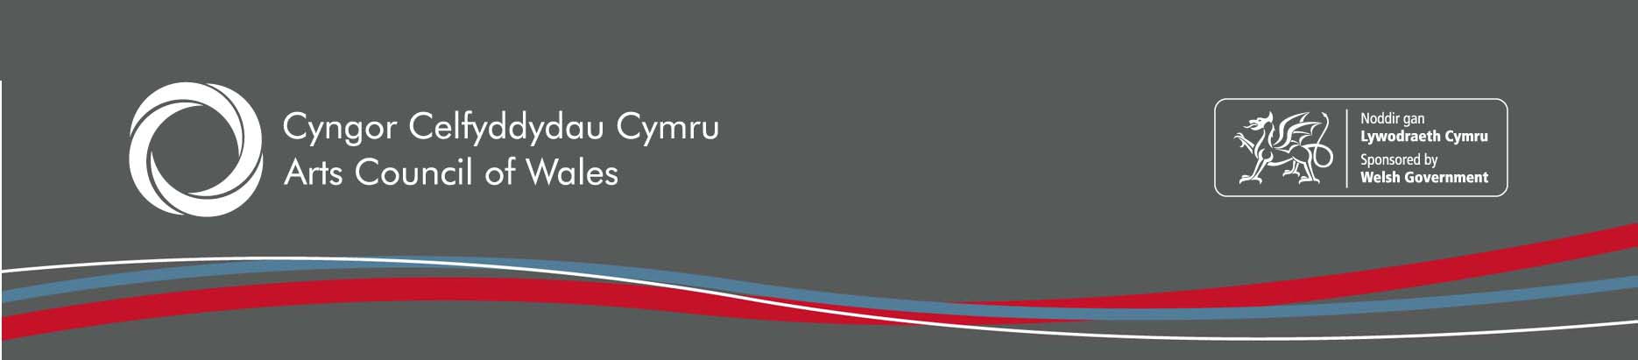

Date: 2020

2019 Wales Omnibus Survey – Adult engagement in the Arts

Introduction
The Arts Council of Wales has conducted an annual population survey into arts attendance and participation since 1993. Information is collected on attendance to arts events and participation in artistic activities via a series of questions asked on the Beaufort Research Ltd Wales Omnibus survey in November. At least 1,000 interviews are conducted each year with a sample designed to be representative of the adult population resident in Wales aged 16 and over.
This paper summarises the latest data on overall arts attendance and participation levels among adults and by key demographic groups.

Key Results

Attendance at Arts Events
Since 2006 survey respondents have been questioned about their attendance to a consistent list of 14 artforms. The graph overleaf shows the proportion of adults living in Wales attending at least one of these 14 artforms at least once a year over the last twelve years.
86.8% of adults surveyed in 2019 said that they attend at least one arts event a year. This latest data is an increase of 2.2 percentage points in attendance levels from the previous year.

Arts Attendance 2009-2019 ten year trend (% attending any of the 14 arts events once a year or more)
Base: All Adults (at least 1,000 per wave) Source: Wales Omnibus survey 2009-2019
- When Cinema is excluded from the analysis, just over 8 in 10 adults (82.4%) surveyed say they attended an arts event. This is a small increase on the previous year’s attendance of 79.6%
- Arts attendance in 2019 continues to correlate with social grade, with those in the higher ABC1 group (the professional, qualified and non-manual workers) showing a greater propensity to attend the arts than those in the lower C2DE groups (the skilled, semi-skilled and unskilled manual workers and non-working people). 93.2% and 79.9% respectively attended arts events in 2019.
- While there has been a slight increase in attendance levels among the ABC1 group of 4.4 percentage points, the C2DE group remained stable at 80%

Arts Attendance by Social Grade (% attending any artform once a year or more)

Base: All Adults (at least 1,000 per wave) Source: Wales Omnibus survey 2009-2019
- Adults in the youngest age group, 16- 24 year olds, are more likely to attend the arts in 2019 than any other age group, with 94.2% attending once a year or more. This compares to 75.9% of those aged 65+. However, it was the oldest age group (65+) that had the greatest increase from the previous year of 5.4 percentage point increase.
- The gap in attendance levels by gender has increased in 2019 to 4.4 percentage points from 2.2 percentage points in 2018. More women than men continue to attend arts events in 2019 with 88.9% doing so at least once a year compared to 84.5% of men.
- As in the previous year, the South Central region has the highest levels of attendance to the arts with 89.1% attending arts events at least once during the year. The only region to experience a decrease was the South West region which fell by 0.4 percentage points to 83.8% in 2019.
- An increase in attendance levels among Welsh speakers in 2019 to 92.3% from 86.9% in the previous year means the gap between Welsh speakers and non Welsh speakers has increased. Attendance levels among non Welsh speakers increased by 1 percentage point from the previous year. The gap between the two groups has increased from 2.9 percentage points in 2018 to 7.3 percentage points in 2019.
- 60.0% of all adults surveyed went to the cinema in 2019 making it once again the most popular artform to attend. As with previous years, the next most popular artform was ‘Other’ Live Music (49.9%), followed by Carnival/Street Art (46.2%) and attendance to plays (35.8%).

Participation in arts activities
A consistent list of seven participatory artforms has been included in the Omnibus survey since 2009. The graph below shows the level of arts participation, in at least one of these activities, over these last nine years.
- Half of all adults (49.3%) surveyed in 2019 say they participate in arts activities once a year or more. This has increased by 3.7 percentage points from the previous year.

Percentage of Welsh adults participating in arts activities once a year or more often

(7 artforms)

Base: All Adults (at least 1,000 per wave) Source: Wales Omnibus survey 2009-2018
- As with arts attendance, participation in the arts also correlates with social grade. In 2019, 53.0% of ABC1 adults participated in the arts compared with 41.0% of C2DEs. There has been little change in the gap between the two groups in 2019 compared to the previous year, with a gap of 12.0 percentage points.

Arts Participation by Social Grade

(% taking part in any activity once a year or more often)

Base: All Adults (at least 1,000 per wave) Source: Wales Omnibus survey 2009-2019
- Half (51.9%) of respondents aged 16-24 indicated that they participated in an arts event at least once a year or more. This group had the highest levels of participation of all age groups, however it was the only age group to decrease from the previous year, by 5.3 percentage points. The age group with the largest increase from 2018 was the 45-64s who had an 8.2 percentage point increase.
- As in previous years, a greater proportion of women than men participated in the arts in 2019 – 52.3% and 46.1% respectively. The gap between men and women has narrowed a little from 8.5 percentage points in 2018 to 6.2 percentage points in 2019.
- The region with the highest levels of participation was the South East region with 57.2% taking part in 2019. This has increased by almost 9 percentage points from the previous year. Lowest levels of participation continue to be in the South West region (42.2%), this was also the case in 2018.

Of the seven participatory artforms, Visual Arts and Crafts is the most popular with just over a quarter (28.2%) of adults participating at least once a year. Music (18.4%), Film and Video making (14.2%), Digital Arts (13.1%), and creative writing (11.5%) were the next most popular participatory art forms.

Frequency
The Arts Council of Wales includes questions on the Beaufort Research Adult Omnibus in November each year. A full report on the dataset will be published in May 2020.

Terms and Definitions
Attendance is experiencing the arts as an audience member.

Participation is active involvement in the arts, such as attending workshops, classes or rehearsals.

Further Information
If you have any comments or queries on this data release or if you would like to be added to our regular users list then please contact our research team. Research@arts.wales

Website: www.arts.wales

Contact
Research and Evaluation Team
Arts Council of Wales
Bute Place
Cardiff
CF10 5AL
Tel: 029 2044 1375
Research@arts.wales

Next Update
May 2020

Fourteen artform categories: Cinema, Musical (not opera), Opera, Ballet, Contemporary dance, Plays, Classical music (concert/recital), Jazz (concert/performance), Folk/Traditional/World Music, Other live music, Art/Craft galleries or Exhibitions, Readings/Storytellings and other Literary Events, Carnivals and Street Arts, Arts Festivals (e.g. Music, Dance, Drama, Literature).
Seven artforms including Music, Drama or Theatrical Activity, Dance, Film Video or Photography, Visual Arts and Crafts, Creative Writing, and Digital Arts.

