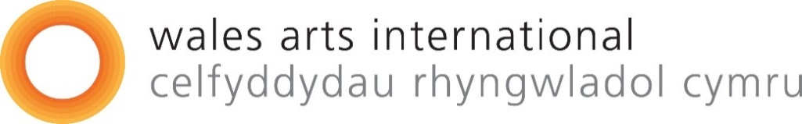

Large print

Gwrando (Listening) Fund

A fund that enables artists in Wales to develop the art of Listening as part of the first year of the UN Decade of Indigenous Languages

September 2022

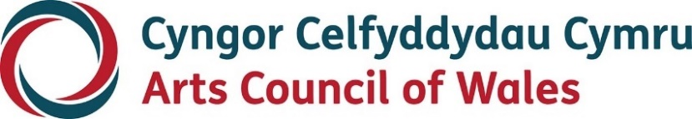
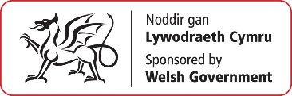
Accessibility
Arts Council of Wales is committed to making information available in large print, easy read, braille, audio and British Sign Language and will endeavour to provide information in languages other than Welsh or English on request.
We operate an Equal Opportunities Recruitment Policy and welcome applications from all sections of the community in Welsh or English. There will be no delays in correspondence due to language preference.
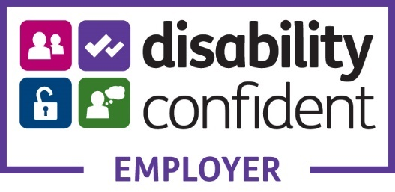

Contents
Introduction 4
The Gwrando Programme 7
About the Gwrando / Listening Fund 10
What does the fund offer? 13
Who can apply? 15
Selection criteria 16
What information do I need to provide 18
What do I need to consider within my proposal? 20
Application Process 21
Supporting documentation 23
Eligibility 24
What we can’t support: 24
What if I have a question or would like access support? 26

Introduction
Wales Arts International (WAI), the international agency of Arts Council of Wales (ACW) is preparing for the next strategic period. A new “international ambition” for the arts in Wales will be co-created during 2022. This will be done within the context of:
- The Wellbeing of Future Generations 7 Goals and 5 Ways of working.
- ACW’s Corporate Strategy development and Investment Review which is in the consultation phase, has currently identified the following 6 priorities:
- Creativity: art that is imaginative, distinctive, international in outlook, ambitiously created in responsible and relevant ways, and that resonates with individuals and communities
- Equity, diversity, and inclusion, so that individuals and communities can make, co-create and experience art on their own terms
- Welsh language thriving in our creative lives: being able to make, participate and experience arts in the Welsh language; and enabling access to, and celebrating its use in, a bilingual and multilingual Wales
- Climate justice via creativity and action that is socially, environmentally, and ethically sustainable
- Nurturing talent for a robust future, with pathways that allow everyone to develop creativity, skills, and leadership
- Transformation: seizing new opportunities and taking risks, being resilient and responsive to change, while remaining relevant to people and communities
- A new Climate Justice strategy and ensuring our work is Carbon neutral by 2030. As ACW works towards developing our strategy and subsequently the resources, support and monitoring tools needed by the sector to make a just transition to a sustainable Wales, we ask you to consider the environmental impact of your activity and the measures you can take to reduce your carbon footprint.
- Our commitments to Welsh Government in its International Strategy and action plans.
Using the 5 Ways of Working, of the Future Generations Act makes us plan and think long term about how the decisions we make today meet the needs of the present whilst protecting the needs of the future in Wales and internationally.
How we involve people from diverse communities in Wales, how we collaborate with our partners internationally and integrate other public bodies’ well-being objectives that might have impact or affect us with our own is important to creating a globally responsible and more resilient Wales within the context of Climate Justice, which of course is by definition an international agenda.
We are ambitious to prevent problems happening or to contribute to climate emergency and injustices using our learning and previous experiences – and those of others - to inform us.

The Gwrando Programme
Wales Arts International, the international agency of Arts Council of Wales, with support by the Welsh Government, is marking the start of the UN Decade of Indigenous Languages in 2022 by launching a new programme for artists and arts organisations. The aim of Gwrando (listening) is to nurture the art of listening to endangered languages and communities, and to learn about their efforts in protecting the land they inhabit.
Listening to indigenous languages through and with other indigenous languages enables deep cultural, creative and linguistic exploration. From these creative explorations we plan to build future collaborations and opportunities. This fund is seen as the first step in venturing deeper during the decade to come. Listening proposals through and with the Welsh language will be especially welcomed but is not an exclusive ask.
A conversation starter by celebrated Welsh poet, and founder of the Peace Academy, Mererid Hopwood calls on us to listen to the linguistic landscape of the world and in particular “to listen to the new possibilities and old wisdoms that are found in the linguistic diversity of the world.”
Through this programme we hope to learn more about the connection between language and the environment. Listening to the diverse languages of the world is as important and beneficial as appreciating the ecological diversity of our natural world.
Mererid Hopwood also calls for an understanding that in some languages and cultures there are more than the five senses that we understand, and that these senses sometimes interplay in unexpected ways. For example, in the Welsh language we hear taste. We also know that we can listen to language and culture without the need for sound. The growing recognition for indigenous sign languages as part of the human rights of deaf and disabled indigenous people is vitally important. This could be an interesting area to also explore through this programme and as part of our commitment to Disability Arts Cymru’s Bring us our Creative Rights Manifesto.

About the Gwrando / Listening Fund
This new Gwrando / Listening Fund forms a part of the Gwrando programme of activity taking place across this first year.
Inspired by the work of artists in Wales and around the world, Gwrando is a learning journey facilitated by Wales Arts International that will include an opportunity for artists based in Wales to listen and learn to connect with indigenous practice around the world through creative means.
The journey will include opportunities, co-designed by participating artists, to listen to indigenous thought leaders and artists and to take part in group sessions. These are designed to be open, supportive spaces to feedback on thoughts and learning points, challenges, and future opportunities.
In this context we use the word Gwrando / Listening as a tool for listening, and not necessarily in the literal sense of hearing. Listening, rather than hearing, enables us to challenge our understanding, and learn. We recognise that there are other senses that are also vehicles that enable us to express and perceive and respond creatively to what we experience. Beyond the sound of a language is its context, culture, and history – all of which can be listened to through multiple senses. As Mererid Hopwood notes at the end of her conversation starter: “beyond listening with languages, speaking them, reading them and writing them, let’s notice how we mediate with them.”
As part of ACW’s commitment to transformation and embedding learning, WAI will be learning along with the artists, and together we will be looking at tools and protocols set by indigenous partners and designed to create safe and equitable spaces. We expect to think again about our own histories with indigenous cultures around the globe by engaging in conversations with thought leaders from indigenous communities, for example in places such as Canada and India where Wales has been part of the British Empire’s colonisation of these countries.
Those on the journey will contribute towards shaping a manifesto of commitments towards working alongside and listening to indigenous languages and cultures worldwide. This may lead to a change in artistic practice and future investment.
Deadline for applications: Monday 19 December 2022 at 5pm

What does the fund offer?
The fund is designed to allow space to listen and to share learning. We are interested in who you want to listen to and why, and how you propose to share this learning.
The total budget available for the fund is £30,000.
The maximum level of support per award is £7,500
For those participants in Wales or internationally not in receipt of a salary for work linked to this project, fees relating to their involvement can be included within the budget.
The fund includes:
- A grant of up to £7,500
- The grant will support:
- your time in participating in up to four days of WAI facilitated learning and sharing activities such as workshops and online check in sessions with other artists and the team as safe spaces to share ideas and learning
- your time in undertaking your proposed activity, associated materials and travel costs
- the sharing of your creative response to your journey. Part of the process will involve discussions around how best to do this.
- All local travel, meals and refreshments for arranged group meetings with WAI in person as part of the programme will be provided in addition to the grant.
We expect the supported projects to start in February 2023 to finish in September 2023.

Who can apply?
The Gwrando / Listening fund is open to arts organisations and individual creative professionals based in Wales.
Dates for workshops for applicants will be shared through our social media.
See help notes for detailed information on eligibility criteria and required bank information.

Selection criteria
Applications will be assessed using the following criteria:
1. The commitment to the overall ethos/aims of the programme
2. The extent to which the applicant’s application reflects the purpose of the fund
3. The quality of creative practice and evidence of track record.
4. The perspective that the proposal brings through lived experience or genuine enquiry.
5. Availability to commit time to it and the viability of the proposal within the time and resources allocated
6. The environmental impact of your activity and travel (if applicable)
In addition to this basic selection criteria, the selectors will take into consideration the potential for the award to impact on the applicant’s creative development and their potential contribution towards shaping a manifesto of commitments to continue the journey of working alongside indigenous languages and cultures.

What information do I need to provide
A proposal in response to the opportunity and the selection criteria that tells us the following:
- why the opportunity offered by the Gwrando / Listening fund is of interest to you and your reasons for wanting to participate
- your proposed approach to the opportunity with an outline timeline. Is there a specific indigenous language or community that you want to engage with and how do you will do this? How will you ensure that you will be culturally sensitive, avoiding cultural appropriation or being extractive?
- what you hope to achieve or learn from this journey, why it is important to your practice and how you think you might share the learnings and experience?
- an overview of your practice and career to date (please provide a link to your CV and examples of your recent work) and your international ambitions. Please include any experience you have had in working with indigenous language communities and / or on collaborative projects with other artists creating safe spaces to connect and listen, explore and share learning around particular themes.
- any relevant information about the language, community, artist or activity you are planning to engage with
- a budget to outline how you would use the grant. Please present this in a simple table in your submission.

What do I need to consider within my proposal?
We would encourage you to consider and address the following if applicable:
- the environmental impact of your activity and travel (if applicable) and how this will guide decisions on the development of the activity and travel
- ensuring that contributors are fairly paid
- the rationale for the activity being in person, digital or hybrid

Application Process
- You’ll need to use our online ‘portal’ to make an application. If you haven’t done so already, you’ll need to register for access to the portal. You can find out how to register here. If you’re unable to access the online form or require further assistance, please contact us at info@wai.org.uk
- Complete a Gwrando Fund application from our online portal. The application form is set out with the following sections, Contacting You, Project Proposal, Artform, Activity Types, Language, Location, Equalities.
- In the Project Proposal section we ask for a short summary of your project. We may use this information in any publicity we produce about your project [character limit 480].
- We then ask for more information about your proposal in response to the points noted in ‘What information do I need to provide’ and ‘What do I need to consider within my proposal’. The character limit on the form is 3000 but you may upload an additional document, if necessary, in order to cover all the points. [Additional document should be provided as text (up to 3 sides A4) contained in a single file (Word or pdf) and text should be no smaller than 12pt and files should not exceed 250MB.]
- After we receive your application, we’ll send you an acknowledgement.
- If your application is eligible, it will proceed to assessment. A panel made up of selected members will be responsible for selecting.
- If your application is successful, we’ll send you an Award Acceptance. The panel’s decisions are final. If you’ve not been successful, we’ll write to explain why and offer an opportunity for feedback.
- Once you’ve signed and returned your Award Acceptance and we’ve verified your details, we’ll release 90% of the award and we’ll pay the final 10% at the end of your project.
The deadline for this fund is 5pm 19 December 2022.
Decisions will be communicated by mid-February 2023.

Supporting documentation
We will need some specific documentation in support of your application:
- A short letter or email from your international partner that notes their support for your project and their commitment to working with you. If they are providing cash or in-kind support to the project, this needs to be confirmed here.
- A continuation document telling us about your project, should you need additional space, to cover the points under the section ‘Project Proposal’.
- You can also upload your CV as a supporting document.
All additional documents can be uploaded as part of the on-line application process.

Eligibility
- Applicants must be based in Wales and be able to apply in the legal name of the individual making the application.
- Have a bank account in your legal name. You can find out what you need to submit here
- We will not accept proposals from applicants currently in fulltime formal education, including postgraduate study

What we can’t support:
- Activity where there is no contingency plan should physical travel not be possible on the planned dates - Projects that are predominantly Wales focussed with an element of digital international artist or company participation (for these projects, please refer to Create)
- Study or formal training
- Participation in or attendance at competitive events
- Activity that has already taken place
- The costs associated with quarantine and Covid testing either in the UK or in another country. These include:
  - costs related to self-isolating before and after travel (including any loss of income)
  - costs related to quarantine on arrival in your destination country
  - costs related to quarantine on return to Wales
  - costs for any fines for breaking the quarantine rules
  - costs that cannot be covered by travel and professional insurance costs caused by Covid.

What if I have a question or would like access support?
Contact us:
Telephone: +44 29 204 1300
Email: info@wai.org.uk
Twitter | Facebook | Instagram

We have a discretionary budget to address any specific access requirements to ensure the opportunity is flexible and inclusive as possible. These costs would be additional to the total grant
We will also be offering bookable surgery sessions which will be advertised through our social media platforms and the news and opportunities page on our website.

