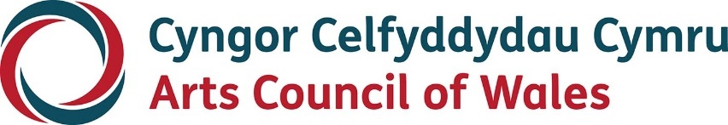

Large print

Creative Steps for Individuals

Help Sheet

November 2022

Accessibility
Arts Council of Wales is committed to making information available in large print, easy read, braille, audio and British Sign Language and will endeavour to provide information in languages other than Welsh or English on request.
We operate an Equal Opportunities Recruitment Policy and welcome applications from all sections of the community in Welsh or English. There will be no delays in correspondence due to language preference.
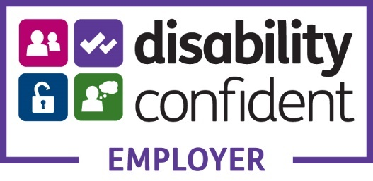

Help sheet for individuals for the proposal and online application
Before you submit your application, you will have discussed your ideas with an Arts Council Officer and received further guidance (if needed) to help you decide whether you are eligible to apply to Creative Steps for individuals, whether you want to and, if so, what to include in your application.
Creative Steps is designed to provide flexible support focussed on you taking the next steps in your creative practice or career – your creative journey. You will need to fill in a short application form but most of the information we will need to consider will be in your ‘Project Proposal’. This should tell us:
- About you and your creative work. Tell us about where you are currently and where you want to be (your goal).
- What you want to use the funding for. Tell us the things what you want to do as the first step towards achieving your goal. (see the Creative Steps for Individuals Guidance document for the type of things this could include)
- How you will decide whether you have achieved your goal for this project.
Your Arts Council Officer will be able to provide guidance to help you prepare your proposal and look over a draft document (if you’re submitting in writing) before you attach it to your application on our portal.
Your Project Proposal can be in provided as a text or audio/video format. We would expect this to be a maximum of 2 sides of A4 or 8 minutes of audio or video. If you would like to apply via audio/video, please click here for further guidance.
If you want to submit a longer proposal or further information, please discuss this with your Arts Council Officer.

Online application, what questions will I need to answer?

Pre–Application Checks
Introductory information and pre–application checklist.

Contacting You
Information about who to contact in relation to the application. This will include your language preferences and bank account information.

About your Project
Key information about your project, including its title, start and end date and basic budgetary information including access support costs.

Project Proposal
Please give us a short summary of your project here. We may use this information in any publicity we produce about your project. This text box can hold up to 480 characters including spaces.

Artform
information about the range of artform activity that will be part of your project.

Activity Types
information about the types of activity that will be part of your project.

Targets
information regarding your proposed project targets, including number of exhibitions, performances, workshops, and audiences/attendees.

Language
the impact you think this project will have on the Welsh Language:
Positive, Negative or Neutral

Location
tell us where your project activity will take place.

Equalities
give us equalities monitoring information for your project.

Review your application
you will see all sections of your application from here. Please check and update if needed.

Pre–submission check
Important: once you click the 'next' button below you will not be able to edit any information provided in the previous sections.
Summary information is displayed here. To make any changes to your answers, click the 'previous' button at the bottom of the page to return to the review tab.

Supporting documentation
Please upload your project proposal and budget.
Your budget can be provided to us as a word document, excel or pdf. A template budget can be found on our website.

Declaration & submit your application
Read declaration and submit your application

Need to get in touch?
For advice regarding your Creative Steps application please contact your Development Officer or email creativesteps@arts.wales
Should you have any technical issues with the application form or your portal account, please contact our Grants and Information team: grants@arts.wales

