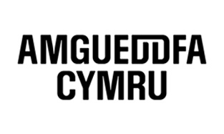
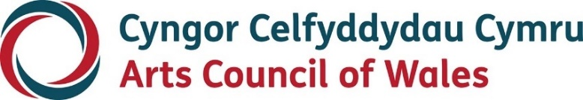

Large print

Perspective(s)

March 2023
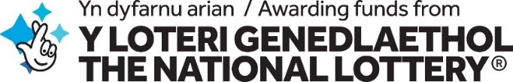
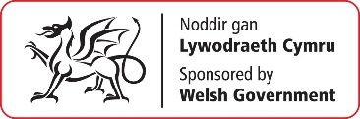

Accessibility
Arts Council of Wales is committed to making information available in large print, easy read, braille, audio and British Sign Language and will endeavour to provide information in languages other than Welsh or English on request.
We operate an Equal Opportunities Recruitment Policy and welcome applications from all sections of the community in Welsh or English. There will be no delays in correspondence due to language preference.
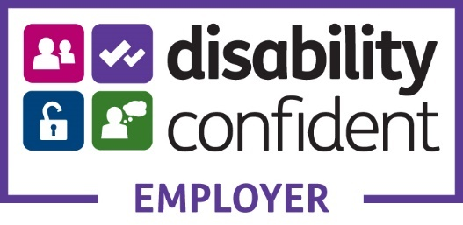

Contents
Accessibility 2
Perspectives 4
Introduction 5
Background 7
About 8
What will the funding support? 12
Who can apply? 14
What will it look like? 16
Selection Criteria 18
Application Process 19
Eligibility 25
Accessibility 25
What if I have a question? 26
Other ways to contact us 27

Perspective(s): bringing our stories together.
Arts Council of Wales in partnership with Amgueddfa Cymru – Museum Wales is pleased to invite visual arts organisations (galleries, commissioning and presenting organisations), based in Wales, to apply to be part of this unique 2-year programme.
Deadline for applications: 8 March 2023, at 5pm

Introduction
Perspective(s): bringing our stories together.
“When we realise that there is never a single story about any place, we regain a kind of paradise” Chimamanda Ngozi Adichie
Perspective(s) is a new collaboration between the Arts Council of Wales and Amgueddfa Cymru designed to bring about a step change in how the visual arts and heritage sector reflects the cultural and ethnic diversity of our society.
Over a 2-year period, creative professionals from culturally and ethnically diverse backgrounds will work with the Amgueddfa Cymru museums and seven visual arts organisations to create new work and displays.
Acting as a critical friend, creative professionals working in the visual arts will explore, question and challenge current ways of thinking within the organisations. They will also engage with community groups to discover new perspectives and stories, aiming to bring about progressive change at an individual, community, and organisational level.
With partnership and co-production at its heart, the two-year period will include a series of public events, creative interventions, exhibitions and displays across Wales. The learning from this programme will be shared to help build a visual arts and heritage sector that is more cohesive, equitable and representative.

Background
Perspective(s) is a joint initiative between the Arts Council of Wales and Amgueddfa Cymru.
The project responds to the commitments made in the Widening Engagement Action Plan, jointly published by Amgueddfa Cymru and Arts Council of Wales in February 2022.
It has received support from Welsh Government as part of its commitment to deliver on the goals in the Anti-Racist Wales Action Plan. The Action Plan is part of the Welsh Government’s Programme for Government and the Co-operation Agreement with Plaid Cymru.

About
Perspective(s) is a unique, 2-year programme for the visual arts and heritage sector in Wales. It focuses on co-design and co-creation, placing lived experience at the centre of creative development and delivery.
The opportunity will support seven visual arts organisations to work in partnership with seven Amgueddfa Cymru museums across Wales.
You can find out more about the seven museum sites here.
We want to support visual arts organisations that are committed to working with inspirational creative professionals and engaging with diverse communities.
Working together the visual arts and museum partner will commission a creative professional to create new work and support them to be an agent of change.
The creative professionals could be artists, makers, curators, writers or other practices, working in the visual arts, that are based in Wales.
The individual will be a critical friend to both partners, supported by, and working with them to explore, question and challenge to inform action. The project aims to bring about progressive change at an individual, operational and systemic level.
Key elements of the programme include:
- Seven visual arts organisations to be selected through an open call process.
- Visual arts organisations will be matched with one of seven Amgueddfa Cymru museums, to form a partnership.
- Each of the visual arts organisations in partnership with Amgueddfa Cymru will co-design a call-out to commission a creative professional, managed and contracted by the visual arts organisation.
- The 2-year period will include a series of public events, creative interventions, exhibitions and displays across the visual arts organisations and the museums.
- Four networking events will be held during the project involving the creative professionals, the visual arts organisations and museums, and may include other groups and stakeholders.
- Evaluation will be led by the Arts Council of Wales in partnership with Amgueddfa Cymru throughout the programme and will aim to disseminate learning to the sector to help deepen understanding and experience of the work.
The commissioning of the creative professional is to be targeted to support individuals who identify as culturally and ethnically diverse.
We define ‘culturally and ethnically diverse’ as:
- Anyone from the African, Asian, Caribbean, Hispanic, Latino, Eastern European or Middle Eastern diaspora in Wales
- Anyone who identifies as being from an ethnic group that is not exclusively White
- Anyone from Gypsy, Roma and Traveller Communities
In addition to this priority, we expect the commissioning opportunities to support applications for individuals from backgrounds who may face barriers due to their sexuality, social and economic background, or identify as Deaf, disabled and/or neurodivergent.

What will the funding support?
A grant of £60,000 will be offered to the visual arts organisation to cover a two-year period from April 2023.
This funding is provided to support:
- A commissioning fee of £25,000 to appoint a creative professional for an estimated 100 days over two years to undertake work with the visual arts organisation and Amgueddfa Cymru museums.
- A facilitation budget of £35,000 for activity with the visual arts organisation to enable engagement, development, production and presentation of the work with creative professionals.
Amgueddfa Cymru will hold a separate facilitation budget for events, interventions, displays and exhibitions to support the work of the creative professionals at the museum sites.
Additionally, we have a discretionary budget to address any specific access requirements, including caring responsibilities, to ensure that individuals leading and delivering activities are supported. These costs would be additional to the total grant. Activities related to engaging participants are not covered by this additional fund.

Who can apply?
Perspective(s) is open to visual arts organisations working and based in Wales.
You should:
- Have an established track record in commissioning creative professionals and presenting visual arts work in Wales with a minimum experience of 3 years.
- Be at a point in your work to significantly benefit from the learning and development offered by this opportunity.
- Demonstrate a genuine commitment and capacity to particate in collaborative working.
- Have a clear rationale for wanting to participate and how your organisation will potentially benefit.
Visual arts organisations that are not gallery based can apply if eligible and meet the programme criteria.

What will it look like?
- Develop narratives and ways of working creatively together that provide a balanced, authentic and decolonised history of Wales and a reflection of Wales today.
- New creative interventions and experiences that the public will both enjoy and that will challenge them.
- Funds and opportunities to work and get experience in heritage and the visual arts for creative professionals from culturally and ethnically diverse backgrounds.
- Reflect and acknowledge the perspectives, experiences, and stories of culturally and ethnically diverse communities, past and present.
- Make space and time for change so that artists, organisations, and communities can talk to each other and come up with new ideas and ways of working.
- Lift barriers and change cultures that currently prevent:
  - work being created,
  - access to artworks, collections and spaces
  - giving communities power.
    - Make sure that the learning along with the new ways of working, become best practice for organisations to work more creatively in cooperation with individuals and communities.
    - Tell the wider arts and heritage sector about what’s been learnt, so they too can get involved in the conversation and take action.

Selection Criteria
Applications will be assessed using the following criteria:
- The extent to which the application meets the purpose of the programme and demonstrates a clear rationale to participate.
- Track record that evidences a strong creative programme and engaging community projects.
- Capacity to participate that demonstrates commitment to empower individuals and drive change.
- The viability of the opportunity within the time and resources allocated.
In addition to the selection criteria, the panel assessing the applications will take into consideration the balance of experience across the group of organisations, the geographical spread across Wales and the potential overall impact towards achieving our aims.

Application Process
- You’ll need to use our online ‘portal’ to make an application. If you haven’t done so already, you’ll need to register for access to the portal. You can find out how to do this here.
If you’re unable to access the online form or require further assistance, please contact us at grants@arts.wales.
- Complete a Perspective(s) application form from our online portal. Guidance for completing the form is available online.
- Your application must be uploaded to the portal as additional material.
Please note, you do not need to outline a specific project within this application. This will be developed in collaboration with the creative professionals.

Your submission should include the following:
- Outline your rationale in applying for Perspective(s).
    - Why do you want to take part?
    - What do you hope to gain or achieve?
    - Why is this the right time for your organisation?
    - Indicate if you have a preference to collaborate with one of the seven Amgueddfa Cymru museums.
- Provide information about your organisation and its track record in the visual arts. You may wish to outline specific examples of anti-racist projects or activity engaging with individuals and community groups and your experience to deliver this.
Include up to four examples of previous work as still images, links to your website or a video showreel (maximum 3 minutes) from an online resource such as Vimeo or YouTube.
- Outline your capacity to deliver this work. Indicating how you would support the creative professionals and their work with community groups and partners?
Include details of the individual/s and role/s that would lead on this work within your organisation and experience to do this. Outline how this would help to inform your work during and beyond the project.
- An indicative budget outlining how you anticipate using the grant. Please use the budget template that you can download from the website.
The facilitation budget of £35,000 could include the following expenditure:
- Realisation of commissioned creative work
- Fees for other collaborators
- e.g other creative team members; artists, filmmakers etc, community members, researchers, academics, historians, advocacy groups, speakers etc
- Facilitation of community conversations
- Travel and subsistence for creative professionals
- Materials for events and/or displays and/or performances
- Training and or mentoring (for creative professionals and/or organisations)
- Administration costs (maximum 10% of total grant)
- Interpretation
- Translation
- Accessibility costs
- Documentation
- Marketing and promotion
The above material (a, b and c) can be uploaded as a maximum of 4 sides of A4. This should be contained in a single file (Word or pdf) and text should be no smaller than 12pt font and files should not exceed 250MB.
All video and audio material must be provided as links to your website, Vimeo or YouTube. Please remember to include security information if links are password protected.
After we receive your application, we’ll send you an acknowledgement.
- If your application is eligible, it will proceed to assessment.
A panel made up of selected members of the Arts Council of Wales, Amgueddfa Cymru and invited members will be responsible for selecting the organisations.
- If your application is successful, we’ll send you an Award Acceptance.
The panel’s decisions are final. If you’ve not been successful, we’ll write to explain why and offer an opportunity for feedback.
- Once you’ve signed and returned your Award Acceptance and we’ve verified your details, we'll release 50% of the award. 25% will be released to you during the project and we’ll pay the final 25% at the end of your project.
Decisions will be communicated by week beginning 20 March 2023.

Eligibility
Applications can be submitted by an eligible organisation. You can check what this means here.
If you’re an organisation and currently have a ‘live’ National Lottery grant open with us you’re still eligible to apply. You’ll just have to make sure that you can meet all the other eligibility and assessment criteria and show you can deliver each project effectively.

Accessibility
Please get in touch with our Grants and Information Team to discuss how we can help with specific access needs.

What if I have a question?
If you want to clarify if you or your application is eligible, or you wish to discuss other questions about this fund, please contact our Grants and Information Team.
You can do this by email, through our website or social media:
Email: grants@arts.wales
Web: Fill out a form on our website
We’ll do our best to respond to all enquiries as promptly as we can. If you want us to call you back, please provide your contact number and we’ll arrange to get back to you as soon as possible.

Other ways to contact us
Telephone: 03301 242733 (all calls charged at local rates)
Hours: 9.00am-5.00pm Monday–Thursday, 9.00am-4.30pm Friday
Website: arts.wales
Twitter: @Arts_Wales_
Instagram: @celfcymruarts

