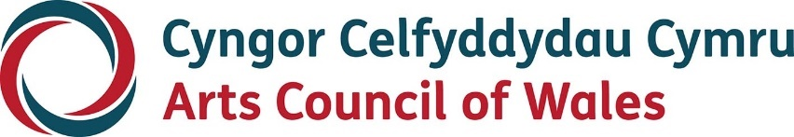

Large print

Annual Report 2023-2024

Strategic Equality Plan 2020-2024
March 2024
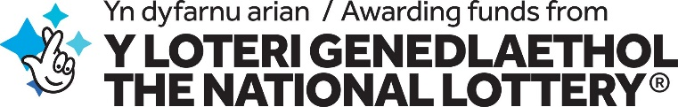
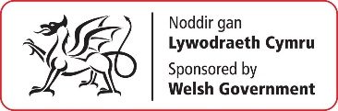

Accessibility
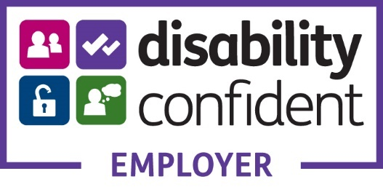
Arts Council of Wales is committed to making information available in large print, easy read, braille, audio and British Sign Language and will endeavour to provide information in languages other than Welsh or English on request. Arts Council of Wales operates an equal opportunities policy.

Contents
Introduction 4
Our Equality Plan objectives 7
What key actions did we progress this year? 9
What challenges do we face moving forward? 22
What does our data tell us about how well we have done? 23
Our Internal Equalities Data 2023/24 – Employees and job applicants 36
Strategic Equality Committee 75
Meeting our Legislative Responsibilities 75
Evidence of the 5 Ways of Working 77

Introduction
The Public Sector Equality Duty sets out specific duties for the public sector in Wales to support and help progress on equalities work. For the Arts Council of Wales, reporting on Equalities is more than a legal requirement, it’s fundamental to the delivery of our core priorities.
Our new 10 year strategy for the arts in Wales states that the role of the Arts Council is to create an environment where the knowledge, understanding and practice of the arts can flourish and where everybody in Wales can engage with the arts. We want a Wales of ambition and fairness where the most exciting arts are created; arts that are integral to the health and wellbeing of the nation, relevant to all communities and where opportunities exist for the voices of Wales to inspire and be inspired by the world around us. This mission is underpinned by six principles, one of which is Equality & Engagement. This principle maintains that:
Everyone has the right to enjoy and take part in our culture, language, landscape, and art. Arts and culture in Wales should reflect the lives of everyone – they belong to us all. We will seek to remove the barriers and challenges faced in experiencing the arts. We will make sure people from diverse communities are fully represented in the workforce, as leaders, decision-makers, creators, visitors, participants and audience members.
Our strategic equalities action plan and our widening engagement action plan asserted our belief as an organisation that culture in Wales should reflect the lives of all its citizens. People who are culturally and ethnically diverse, neuro-divergent, deaf and disabled people, LGBTQ+ people and people facing social-economic disadvantage are integral and central to our cultural life. Our approach in taking forward our work is one of zero tolerance to racism and ableism and we continue to work towards ensuring people from these communities are fully represented in the workforce, as decision makers, as visitors, as creators, participants and as audience members.
Our vision is for a fair and equal Wales where the arts are widely and easily available for everyone. We’re determined to champion diversity and to break down the barriers that prevent this from happening.
“A key focus for our work in 2023-24 was concluding our Arts Investment Review. This was a key programme of work at the heart of achieving significant progress against all of our equality objectives. The process had been designed to achieve a significant transformation in the number and type of organisations in receipt of multi year funding from us, with a particular focus on addressing our equalities and widening engagement agenda. The outcome of the review clearly signified our intention to transform and our ongoing commitment to equity and equality across the sector. We saw an increase in the number of organisations led by disabled people and people from culturally and ethnically diverse backgrounds and a more meaningful and improved commitment from arts organisations across the whole sector to ensuring equality and widening engagement is at the heart of their work.
2023-24, the final year of our current strategic equality action saw a real step change in the arts in Wales and real progress in advancing our equalities aims.”
Devinda De Silva, Chair, Strategic Equality Committee

Our Equality Plan objectives
Our 2020-2024 plan has five objectives. These are:
• Engage, consult with and inform our partners and the communities we aim to reach and in so doing challenge and question our knowledge and experience.
• Develop a workforce that reflects the diversity of Wales by increasing the number of people with protected characteristics employed in the arts and represented in the governance of arts organisations.
• Work to eliminate pay gaps across the arts sector and ensure fair and equal pay for all artists working in Wales.
• Increase the number of diverse artists and arts organisations accessing funding and support to create and present their own art on their own terms.
• Increase the diversity of those engaging with the arts as audience members and creative participants.
These five objectives cover all protected characteristics. However, when we published our new plan in 2020 we continued to give specific emphasis to increasing engagement amongst people from culturally and ethnically diverse backgrounds and deaf, disabled and neurodivergent people.

What key actions did we progress this year?

Arts Investment Review
This was our key programme of work in the final year of the current strategic equality action plan and one that dominated the work of the Council as a whole. The programme was designed to progress all of our equality objectives and bring about real change to the arts sector in Wales. The final decision process took place during 2023/24.
In the previous year we had led an open consultation to inform our design of the application process which we believe contributed to a record number of applications, with 139 organisations eligible for investment compared to 94 in 2015.
Access considerations were core to the application process – we were open to audio and film applications although none were received and following our now established procedures access support was available to applicants.
The process had introduced our six principes, including, Widening engagement, as the main assessment criteria. The decision making process also incorporated five balancing factors which included serving communities across Wales; underfunded and unheard voices and the size and shape of applicant organisations.
We included broader perspectives by engaging associates as part of the assessment process.
The outcome of this Investment Review is a greater range of diversity in the arts in Wales, with funding for more culturally and ethnically diverse led organisations, including Fio and Urban Circle, Taking Flight as well as an increased representation on boards of D/deaf and disabled people. We increased the level of funding to thirteen organisations that were already funded by us, including Disability Arts Cymru, Hijinx and Jukebox Collective.
Through the process we identified areas where we need to make further strategic interventions to address gaps or issues. Our commitments include supporting RAMPS Cymru or Craidd to improve the representation of disabled people across the theatre sector in Wales, and a review of traditional music. We have allocated an additional £1.4 million towards these actions which are now being taken forward.
Serving communities across Wales was a key consideration in our decision making. We have reduced funding to some organisations based in Cardiff and there are increases in a number of local authorities including Wrexham, Newport, Bridgend, Merthyr Tydfil, and Pembrokeshire. However, we acknowledge that less funding will be going to some areas including Blaenau Gwent, Caerphilly, Conwy, Denbighshire, Neath Port Talbot and Torfaen. We are committed to developing relationships with these local authorities and other local stakeholders to explore how we can best support the arts offer that these communities deserve.
It was pleasing that many organisations that applied, approached the Widening Engagement principle in an honest and self-reflective way, with a commitment to rectifying shortcomings rather than being satisfied with what is currently being done. Most applicants considered the experiences of D/deaf, disabled and neurodivergent artists, and tried to engage with issues surrounding access and accessibility. However, there were some instances where organisations only focused on one element of Widening Engagement. Unfortunately, the weakest element in many applications was related to ethnically and culturally diverse communities. The applications that were intersectional in their approach stood out in the assessment process. For example, Tanio, a community arts organisation based in Bridgend, is taking a proactive approach to widening engagement and intersectionality by working with people of the Global Majority, including Welsh-speaking people of the Global Majority; for example, the organisation is ensuring that there are pathways to using the Welsh language built into the Black History Month project.
Significantly, a number of the organisations achieving funding for the first time had been developed through our Creative Steps scheme. These were Fio, Jukebox, Taking Flight Theatre and Urban Circle are among the past beneficiaries.
We know there is still work to do to bring greater diversity and representation to the sector and our next Strategic equality plan 2024-28 will set out the key aims and actions we intend to put in place to address continue to progress this work.

Creative Steps
Creative Steps is a major fund that aims to address the barriers individuals face in accessing our funding and the marginalisation of certain communities. The scheme is focused on supporting artists or arts organisations that are ethnically and culturally diverse, deaf, disabled and/or neurodivergent, specifically those that have experienced barriers to funding and discrimination.
In 2023-24, 8 organisations and 63 individuals received funding through the Creative Steps scheme, with the total amount awarded being £1,075,024. In this year we also began a review of the scheme.

Widening Engagement Action Plan 2022-25
We continued to progress our work on the delivery of the Widening Engagement Action Plan in partnership with Amgueddfa Cymru. With the support of the Widening Engagement Task Force we focussed on evaluation and communications.
A key project in the action plan was Perspectives, a joint project with Amgueddfa Cymru, supported through Welsh Government’s Anti Racist Wales funding
Case Study: Perspective(s) is a unique collaboration between the Arts Council of Wales and Amgueddfa Cymru, where we are pooling our resources, staffing and knowledge. It seeks to bring about a step change in how the visual arts and heritage sector reflects the cultural and ethnic diversity of our society. It focuses specifically on two aspects in the Anti-racist Wales Action Plan: Developing the Historical Narrative and Celebrating Diversity. The project aims to:
- Decolonise public spaces and collections to ensure they offer balanced and inclusive narratives that acknowledge links to colonialism, slavery, and Empire.
- Develop diverse Creative Professionals, by giving them meaningful opportunities in the arts and heritage sector and ensuring they have exposure for their work
- Work with culturally and ethnically diverse communities to ensure their voice is reflected and represented in the arts and heritage sector and that they are involved in cultural production and have access to spaces and collections
- Develop creative outputs and experiences that will engage but will also challenge audiences and that can be used as a catalyst for learning
- Develop new ways of working within our organisations that are democratic, inclusive, and intersectional and can become best practice within the sector.
The approach for Perspective(s) is a collaborative one. It brings together each of the seven National Museums to work in partnership with a Visual Arts Organsiation. In turn, they have recruited a Creative Professional and then collectively they are working with communities and critical friends to meet the Perspective(s) aims.
Perspective(s) has been a continuous learning process. We are learning by doing, through delivering the programme and overcoming challenges. The creative professionals are exploring decolonisation in a much broader sense than we may have initially anticipated. They are thinking about where power lies in organisations, they are thinking about relationships between themselves and organisations, and exploring ways of shifting power dynamics and they are developing more inclusive ways of working
Another key piece of work taken forward in this year was the second phase of our disability focussed research. This work focussed on exploring the development of minimum standards of access to arts venues and museums. Richie Turner Associates were commissioned to undertake this research, working with:
● Trevor Palmer: Physical Disability and Learning Disability Consultant
● Jonny Cotsen: D/deaf Consultant
● Chloe Clarke: Visually impaired consultant
● Jon Luxton: Disability Advisor and External Policy Consultant
● Lyndy Cooke: Deputy Project Manager and Access Support Manager
● Cooked Illustrations: Illustrations
UCAN Productions and Arcadian Owls Productions were also commissioned to create a series of films exemplifying the standards.
The report and recommendations will be published in Autumn 2024.

Hynt
As of January 2024 31,707 cards have been issued and 45 venues are members of the Hynt scheme, with an additional 4 associate members, one of which was Amgueddfa Cymru - National Museums Wales.
The Hynt Impact Report, (link) funded by Arts Council England and written by Milestone Tweed, was published in November 2023. The opportunities the data has given Creu Cymru to demonstrate the impact, to network and present the learning has been powerful, including a presentation to the Welsh Government Culture Divisional Meeting, Arts Branch Lead in February 2024 and Hynt being shortlisted for Community Project of the Year at the Stage Awards.
Work has continued with ACE and other arts council on the development of a UK wide arts access card scheme now formally known as AllIn (link), based on the model developed in Wales. As part of our MoU with ACE we commissioned Andrew Miller as the Arts Access Champion to lead high profile discissions across the nations and to raise the profile of this important initiative.

Agent for Change Report 2021-2024
2023-24 saw the start of the third year of our Agent for Change. During this year this role continued to be an important voice in the delivery and monitoring of our Widneing Engagement Action Plan. Taking on rotated chair of the Task Force, leading our work on communications and bringing a conciliatory voice into our Perspectives project.
Our Agent for Change also co-chaired the Creative Steps fund, a major fund related to redressing the marginalisation of certain communities and democratising our funding. As co-chair, our Agent for Change worked on the strategic elements of the fund such as the guidelines, the Associates involved in the programme, the chairing of the Programme Group (internal group leading on the scheme) and the chairing of decision meetings. In addition he has supported potential applicants raised the profile of the fund across a number of networks.
Alongside Yaw Owusu (POWER UP co-ordinator), we have been leading on targeted work within Wales to support Black musicians and Black industry professionals to eradicate barriers to progression in the music industry. During the life of this strategic equality plan, our Agent for Change has been working to support Welsh musicians through the POWER UP programme. Successful applicants have received up to £15,000 funding, access to mentoring and marketing support, access to the POWER UP network and bespoke support in their career. To date, LEMFRECK, Aleighcia Scott, Tumi Williams, Mace The Great and Mirari have been supported on the programme.
The future of this work is being secured through the creation of a Welsh Black Music Action Group. The Welsh Black Music Action Group (WBMAG) is a consortium of music industry professionals and creators that have come together to address the systemic barriers and inequalities that Black artists and professionals face within Wales. The purpose of the group is to drive forward change to ensure better equality, inclusion, visibility and equity for these artists and professionals in Wales, and also to help export MOBO music being created in Wales to a national and international audience, whilst also providing a platform and an infrastructure for these artists and professionals to thrive in Wales as well.

What challenges do we face moving forward?
One of the areas we still need to make progress on as we move into our new strategic equality action plan is workforce development. Although progress has been made through our Investment Review and the implementation of key projects and programmes, we are still seeing people with protected characteristics under-represented in the arts in Wales and significant amongst these is representation in our own workforce.

What does our data tell us about how well we have done?

Arts Portfolio Wales 2023-24
N.B.: Two organisations did not submit their final APW survey for the second half of FY 2023/24. Their Employees and Governance Equalities data is thus missing from the statistics presented below.
In 2023-24, a total of 1,920 people were employed by 65 of our Arts Portfolio Wales organisations. 6.6% of these identified as D/deaf or Disabled, 7% as being from a cultural and ethnically diverse background, and 10.5% as Lesbian, Gay or Bisexual. 11 employees identified as transgender. 20.7% of employees were 50+ years old, and 13.6% were between the ages of 16 and 25 years old. 10.7% of employees indicated holding specific religious beliefs. There were 29 women who were pregnant or on maternity leave – 2.1% of employees.
In all these categories we are seeing a reduction compared to the previous year.
The total number of people on Arts Portfolio Wales Boards of Management were 523. Of these, 12.6% identified as D/deaf or Disabled, 11.5% as being from a cultural and ethnically diverse background, and 14% as Lesbian, Gay or Bisexual. No board members indicated identifying as transgender. Nearly half (47.2%) were 50+ years old, and 2.1% (11) were 16 to 25 years old. 14.3% of board members held specific religious beliefs. 7 boards members were pregnant women or on maternity leave – 1.3% of all APW board members.
This year saw an increase in the number of people identifying as deaf or disabled but a notable decrease in the number people form a culturally and ethnically diverse background.
Employee Data | 2022/23 | 2023/24** | % Change | % of overall employees 2022/23 | % of overall employees 2023/24**
Total number of Employees | 1,969 | 1,920 | -2.49 | - | -
Total number of D/deaf or disabled employees | 143 | 126 | -11.89 | 7.26 | 6.56
Total number of Culturally and Ethnically Diverse employees | 146 | 135 | -7.53 | 7.41 | 7.03
Total Lesbian, Gay or Bisexual people | 251 | 201 | -19.92 | 12.75 | 10.47
Total Older People | 424 | 397 | -6.37 | 21.53 | 20.68
Total Young People | 277 | 261 | -5.78 | 14.07 | 13.59
Total People with specific religious beliefs | 257 | 206 | -19.84 | 13.05 | 10.73
Total Women who are pregnant or on maternity leave | 30 | 29 | -3.33 | 1.52 | 1.51
Total Transgender people | 19 | 11 | -42.11 | 0.96 | 0.57
*Denotes number supressed to avoid individuals being identified
**2 organisations missing data

Boards of Management Data | 2022/23 | 2023/24** | % Change | % of overall employees 2022/23 | % of overall employees 2023/24**
Total number on Boards of Management | 567 | 523 | -7.76 | - | -
Total number of D/deaf or disabled People on Boards of Management | 38 | 66 | 73.68 | 12.6 | 12.6
Total number of Culturally and Ethnically Diverse People on Boards of Management | 77 | 60 | -22.08 | 11.5 | 11.5
Total Lesbian, Gay or Bisexual People on Boards of Management | 65 | 73 | 12.31 | 14.0 | 14.0
Total Older People on Boards of Management | 241 | 247 | 2.49 | 47.2 | 47.2
Total number of People on Boards of Management with specific religious beliefs | 102 | 75 | -26.47 | 14.3 | 14.3
Total number on Boards of Management who are pregnant or on maternity leave | 11 | 7 | -36.36 | 1.3 | 1.3
Total Transgender People on Boards of Management | * | * | N/A | N/A | N/A
Total Young People on Boards of Management | 13 | 11 | -15.38 | 2.1 | 2.1
**2 organisations missing data

Lottery
In 2023/24, 29.4% of all lottery awards went to projects targeting D/deaf or Disabled people. This made up 33.4% of total funds awarded, at £4,665,250. 19.5% of lottery funded projects targeted culturally and ethnically diverse audiences, cumulating to £2,500,455. Projects targeting Children & Young People made up 13.6% of funded lottery projects. They received 19.5% of total funds awarded, at £2,734,091. Projects targeting Older People and LGB audiences made up similar proportions of all lottery-funded projects (7.4% and 7.3% respectively). However, projects targeting Older People received 9% of lottery funding, compared to 6.4% for projects targeting LGB people – a £360,038 difference.
Overall, between 2022/23 and 2023/24, funding decreased for projects targeting:
- Culturally and ethnically diverse people,
- Children and Young People
However, funding increased for projects targeting:
  - Older People,
  - D/deaf or Disabled People,
  - Lesbian, Gay or Bisexual People.
  - 32% of awards went to recipients identifying as D/deaf or Disabled – a 40% increase since 2022/23 (the largest increased out of all protected characteristics).
  - Lesbian, gay or bisexual recipients made up just over a quarter of recipients (26%), but the total value of awards they received was just below a quarter, at £826,381.
  - Culturally and ethnically diverse recipients received close to a quarter of the total value of lottery awards (24%), at £800,903.
  - Funding to young people (25 yo and younger) decreased slightly, from 9.4% to 7.6% of all awarded projects, and by £110,777.
  - Over half of individual recipients were female, with a total value of £1,705,805 awarded. While the percentage of awards to female recipients increased 4% (71 more awards than the previous year), the overall percentage of funding they received decreased by 13%. Conversely, the percentage of awards to males also increased 4% but the proportion of all awards this represented increased by 32%. This is a 19% funding increase per capita for male recipients, and a 21% per capita decrease for female recipients.
In 2023/24, the largest proportion of awards and value of awards was to organisations led by Older People. This represented near £3.6M in total. Organisations led by ethnically and culturally diverse people received 18% of all awards (£1,826,874), a 89% rate of increase since 2022/23. 14% of all awards went to D/deaf or Disabled led organisations, 13% of the total value of lottery awards (£1,340,218). The biggest rate of increase in proportion of all awards and total value of awards was to LGB-led organisations – receiving 2.3% of all awards in 2022/23 to 12% in 2023/24. They received £1,242,326. The smallest portion of awards went to organisations led by young people - 2% of all awards (£148,186).

Projects targeted at specific groups
Protected Characteristic Group | Number of Awards | Total Value of Grant | % of all awards | % value of all awards
Culturally and Ethnically Diverse people | 131 | £2,500,455 | 19.5 | 17.9
Children & Young people | 92 | £2,734,091 | 13.6 | 19.5
Older People | 50 | £1,257,198 | 7.4 | 9.0
D/deaf or disabled people | 198 | £4,665,250 | 29.4 | 33.4
Lesbian, Gay or Bisexual People | 49 | £897,160 | 7.3 | 6.4

Individuals
Protected Characteristic Group | Number of Awards | Total Value of Grant | % of all awards | % value of all awards
Culturally and Ethnically Diverse people | 71 | £800,903 | 23.4 | 24.0
Young people | 23 | £231,104 | 7.6 | 6.9
Older people | 76 | £840,381 | 25.1 | 25.2
D/deaf or disabled people | 97 | £1,134,525 | 32.0 | 34.0
Male | 119 | £1,420,850 | 39.3 | 42.6
Female | 166 | £1,705,805 | 54.8 | 51.1
Lesbian, Gay or Bisexual people | 81 | £826,381 | 26.7 | 24.8

Boards of Management
Protected Characteristic Group | Number of Awards | Total Value of Grant | % of all awards | % value of all awards
Culturally and Ethnically Diverse Led Organisations | 65 | £1,826,874 | 17.6 | 17.20
Children & Young People Led organisations | 7 | £148,186 | 1.9 | 1.40
Older Person Led Organisations | 124 | £3,596,652 | 33.5 | 33.80
D/deaf or Disabled Led Organisations | 53 | £1,340,218 | 14.3 | 12.60
Male Led Organisations | 97 | £2,952,823 | 26.2 | 27.72
Female Led Organisations | 140 | £3,896,841 | 37.8 | 36.59
LGB Led Organisations | 32 | £1,242,326 | 8.6 | 11.70
N.B.: An organisation is deemed to be led by a protected characteristic if 51% or more of its board meets the criteria for that characteristic.

Our Internal Equalities Data 2023/24 – Employees and job applicants

Introduction
This report covers the financial year 2023/24. The data presented related to all staff employed by the Arts Council of Wales during that period and all external job applicants. Where possible, data from the 2021 Census has been included as a comparison.
All applicants are asked to complete an equality, diversity and inclusion monitoring form and all new starters are encouraged to update the personal details section in our HR system (Cascade) which includes disability status, ethnicity and other personal characteristics. Reminders are sent to all staff a twice a year, reminding them of why we ask them for this information. Staff are aware of the ‘prefer not to say’ option. Nevertheless, some staff have yet to update this information although we have seen an improvement compared with previous years.
As mentioned above, we ask all external job applicants to complete and submit an Equality, Diversity and Inclusion Monitoring Form when submitting their application. During the past year, 87% of applicants completed the form when asked to do so compared with 98.3% of applicants during the 2022/23 financial year, 96.6% in 2021/22 and 73.2% in 2020/21.
Our Equality, Diversity and Inclusion Monitoring Form was updated twice in 2021/22 and in 2024. In 2021/22, we worked with the Arts Council’s research team and with Stonewall and Chwarae Teg to revise the categories and options included on the form, as well as the terminology used. Later in the year we worked with the Welsh Language Enabler/Ysgogwr y Gymraeg to amend the information that we asked applicants in relation to the Welsh language. Previously we only asked for language preference, but now we ask about Welsh language ability and learning status.
In 2024, following a request from the Strategic Equalities Committee, the form was revised to remove the section asking the applicant to tick the ‘type’ of disability under the social model. The requirement for the applicant to select the ‘type’ of disability from the legal model will be removed as well, effective from September 2024. We will now only ask applicants to provide a ‘yes’, ‘no’ or ‘prefer not to say’ answer.
4 roles were recruited via agencies, and EDI data were not shared with us.
In any graph where an asterisk (*) appears, this indicates that the data for that category where 5 or below individuals hold this characteristic has been suppressed to ensure anonymity and that any individuals cannot be identified.

Gender
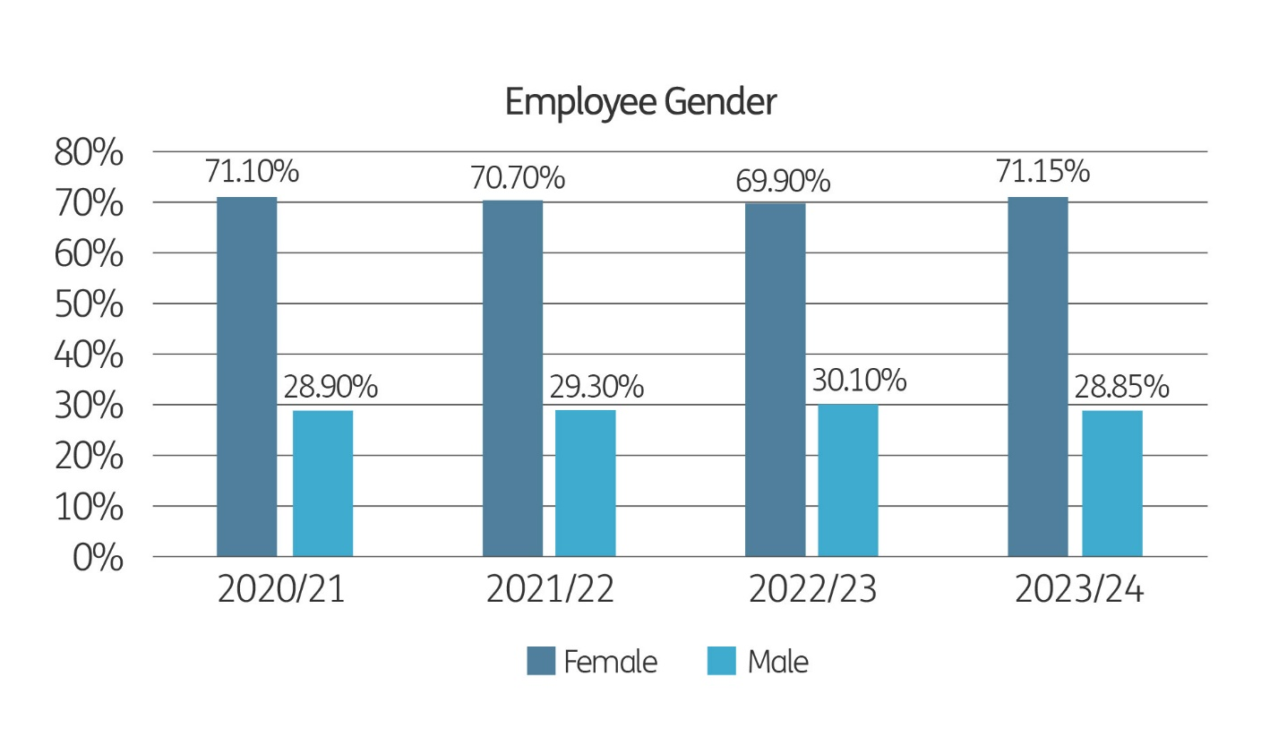
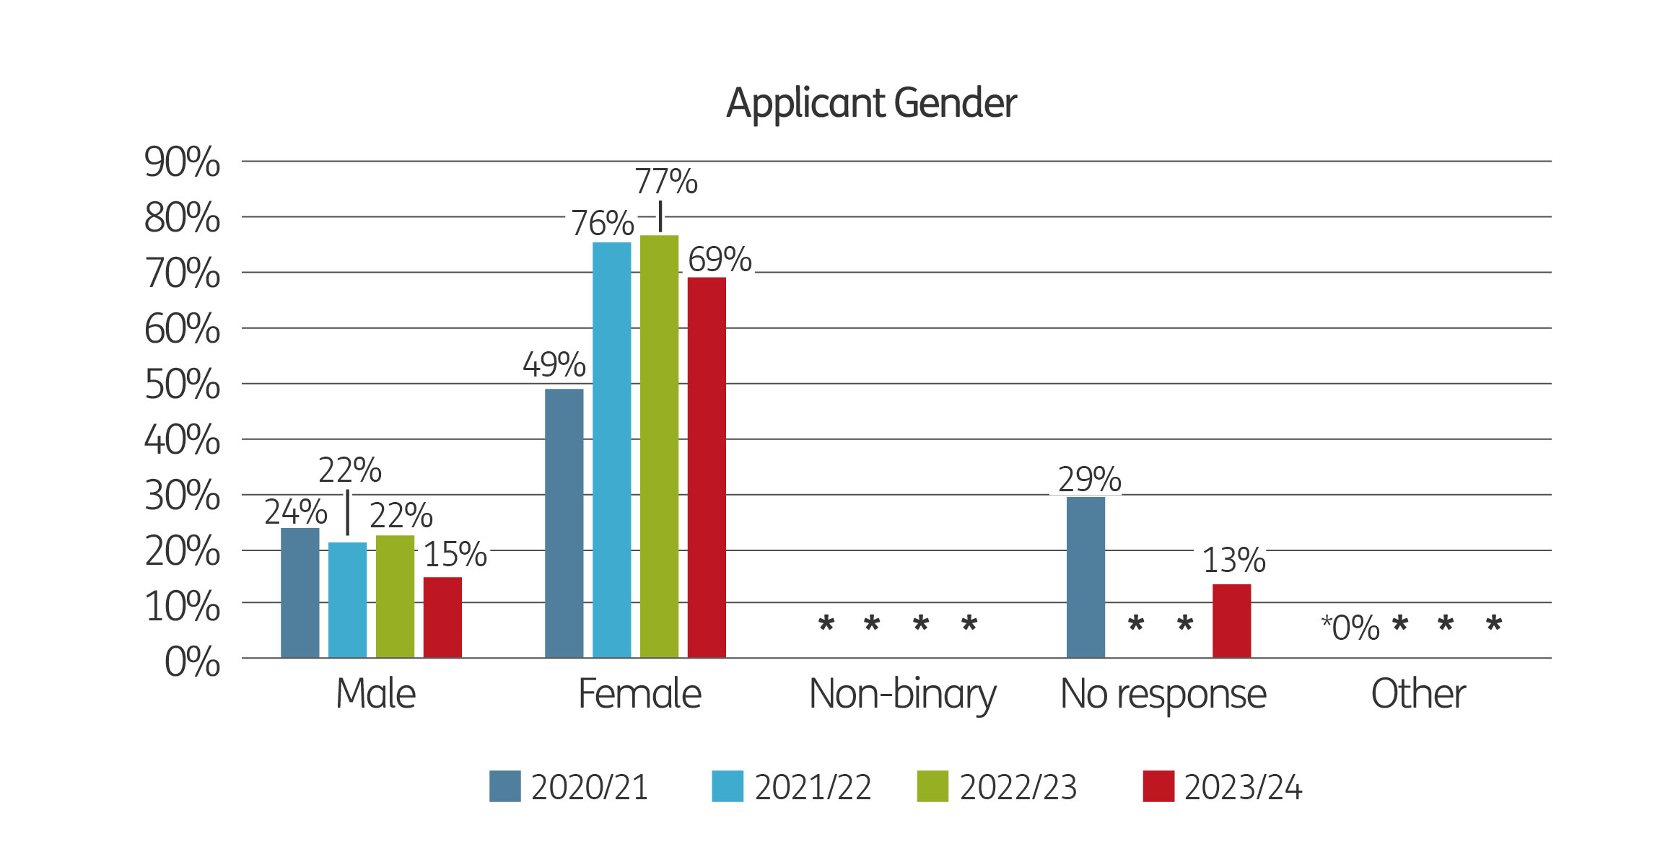
The percentage difference of female and male employees is smaller than the percentage of female and male applicants – the percentage of male employees is roughly 10% higher than the percentage of male applicants, however, there is a long way to go in terms of a gender balance. The figures for non-binary, other gender and no response have been suppressed to ensure anonymity and that the data cannot be identifiable.
We may consider using positive action to attract more males, non-binary and other genders in future recruitment campaigns.

Relationship status
The graphs below show the relationship status of employees and applicants during this, and the three previous, financial years.
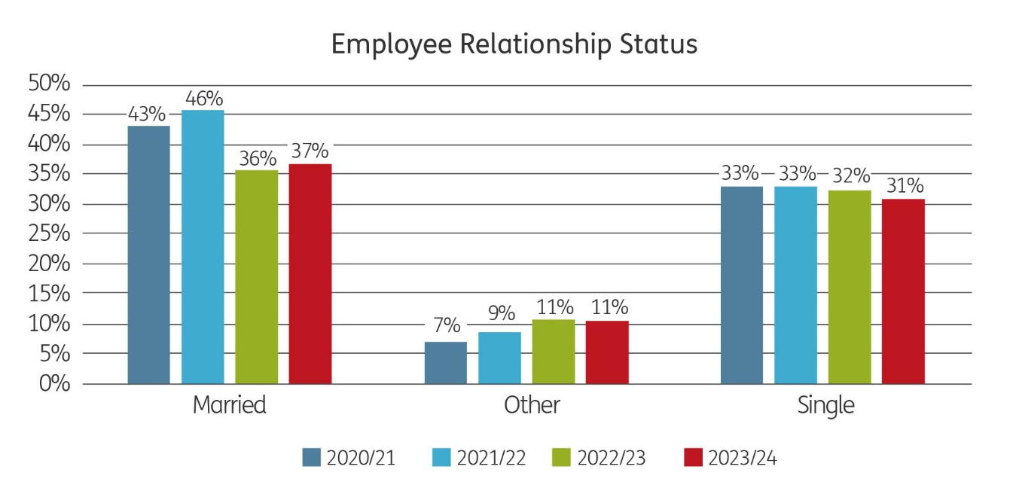
The data for the categories divorced, living with partner, separated and widowed have been suppressed and have not been included in the graphs so as to show the graph more clearly.
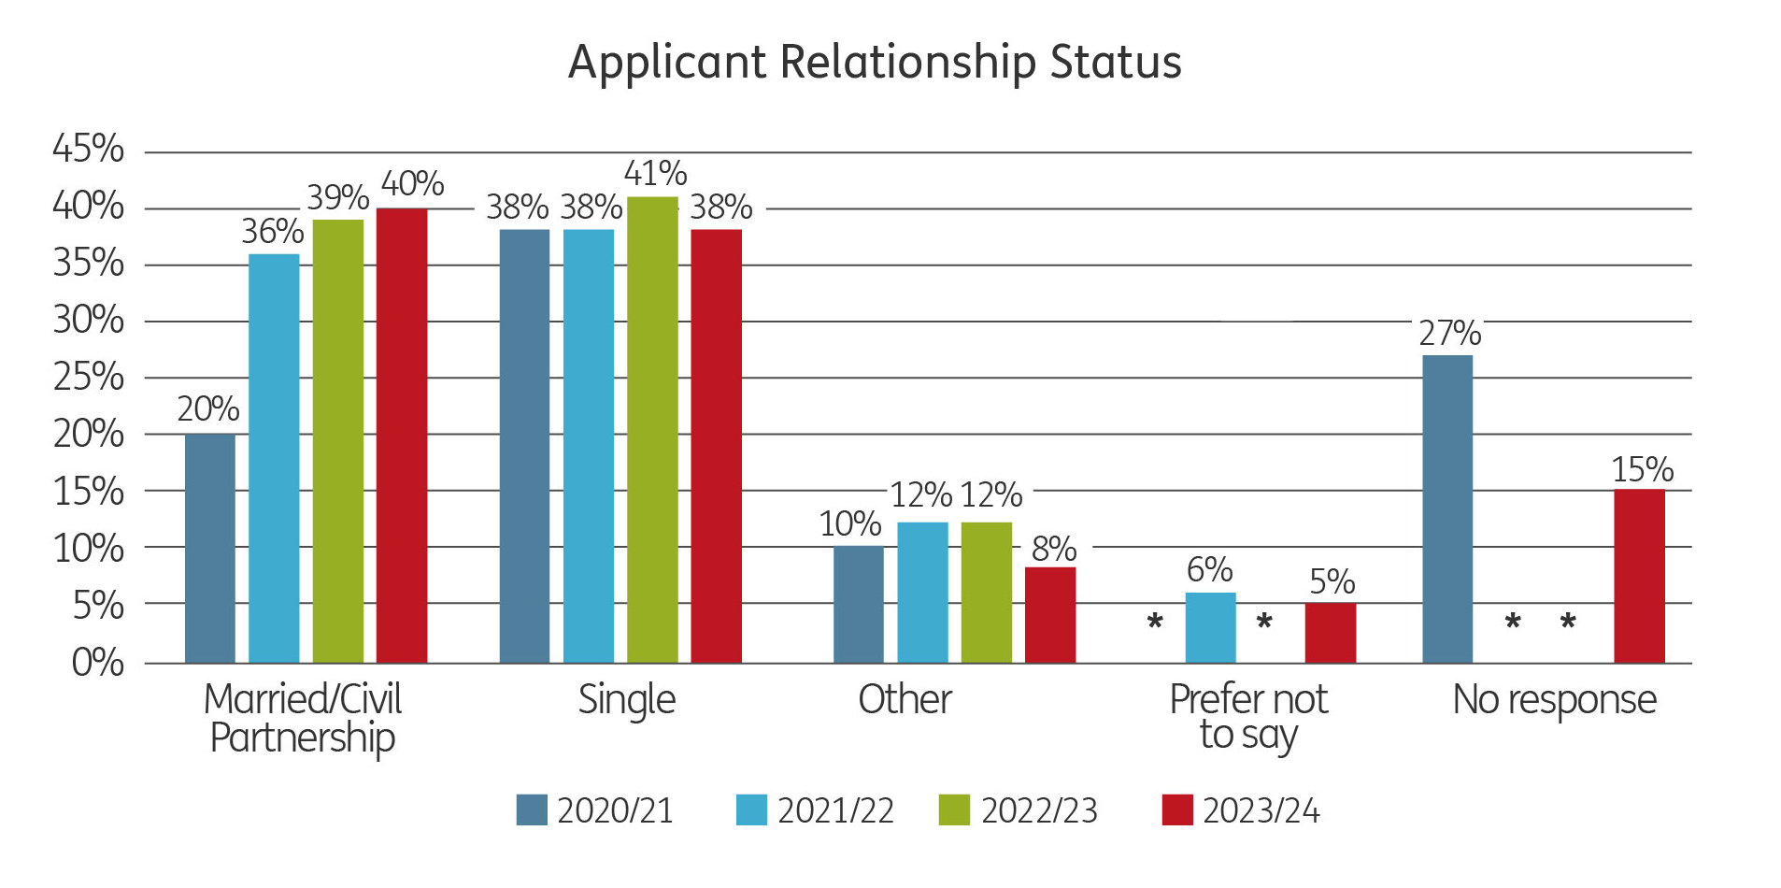
A slightly larger proportion of staff are single compared with applicants, with a similar percentage of staff and applicants indicating other relationship categories.
The most recent Census data is that of 2021, and when we compare that data with that of staff and applicants, we can see that the percentage of married applicants and employees or those in a civil partnership is only slightly lower than the census data.
We do not use positive action to attract applicants of a particular relationship status.
2021 Census Data: Marital Status | Wales
 | number | %
Single. Never married and never registered a civil partnership | 951,657 | 37.18%
Married or in a registered civil partnership | 1,121,459 | 43.82%
Separated, but still legally married or still legally in a civil partnership | 52,469 | 2.05%
Divorced or civil partnership dissolved | 252,707 | 9.87%
Widowed or surviving civil partnership partner | 181,126 | 7.08%
Single. Never married and never registered a civil partnership | 951,657 | 37.18%

Sexual orientation
The graphs below show the sexual orientation of employees and applicants during this, and the three previous, financial years.
The data for the category gay/lesbian, and for employees the category bisexual, have not been included in the graphs as the data may be identifiable.

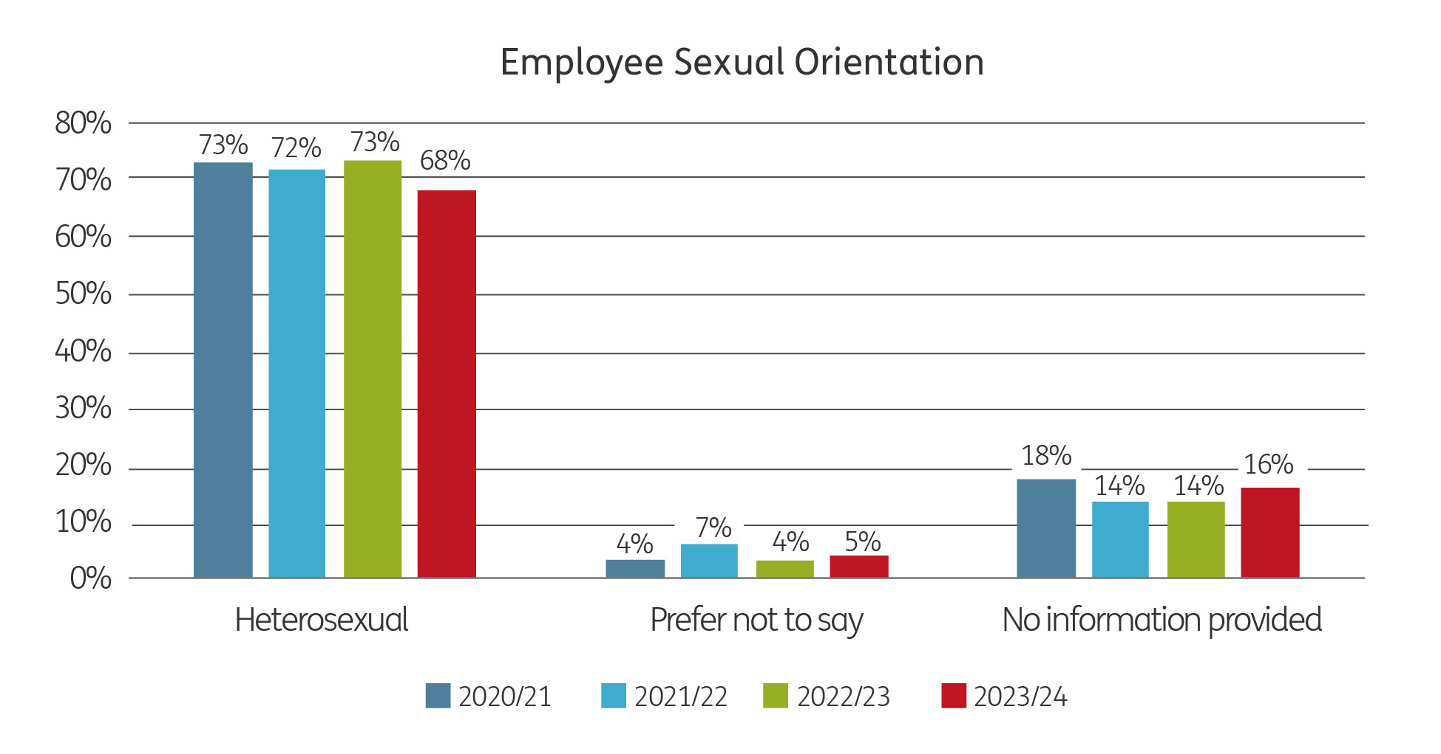

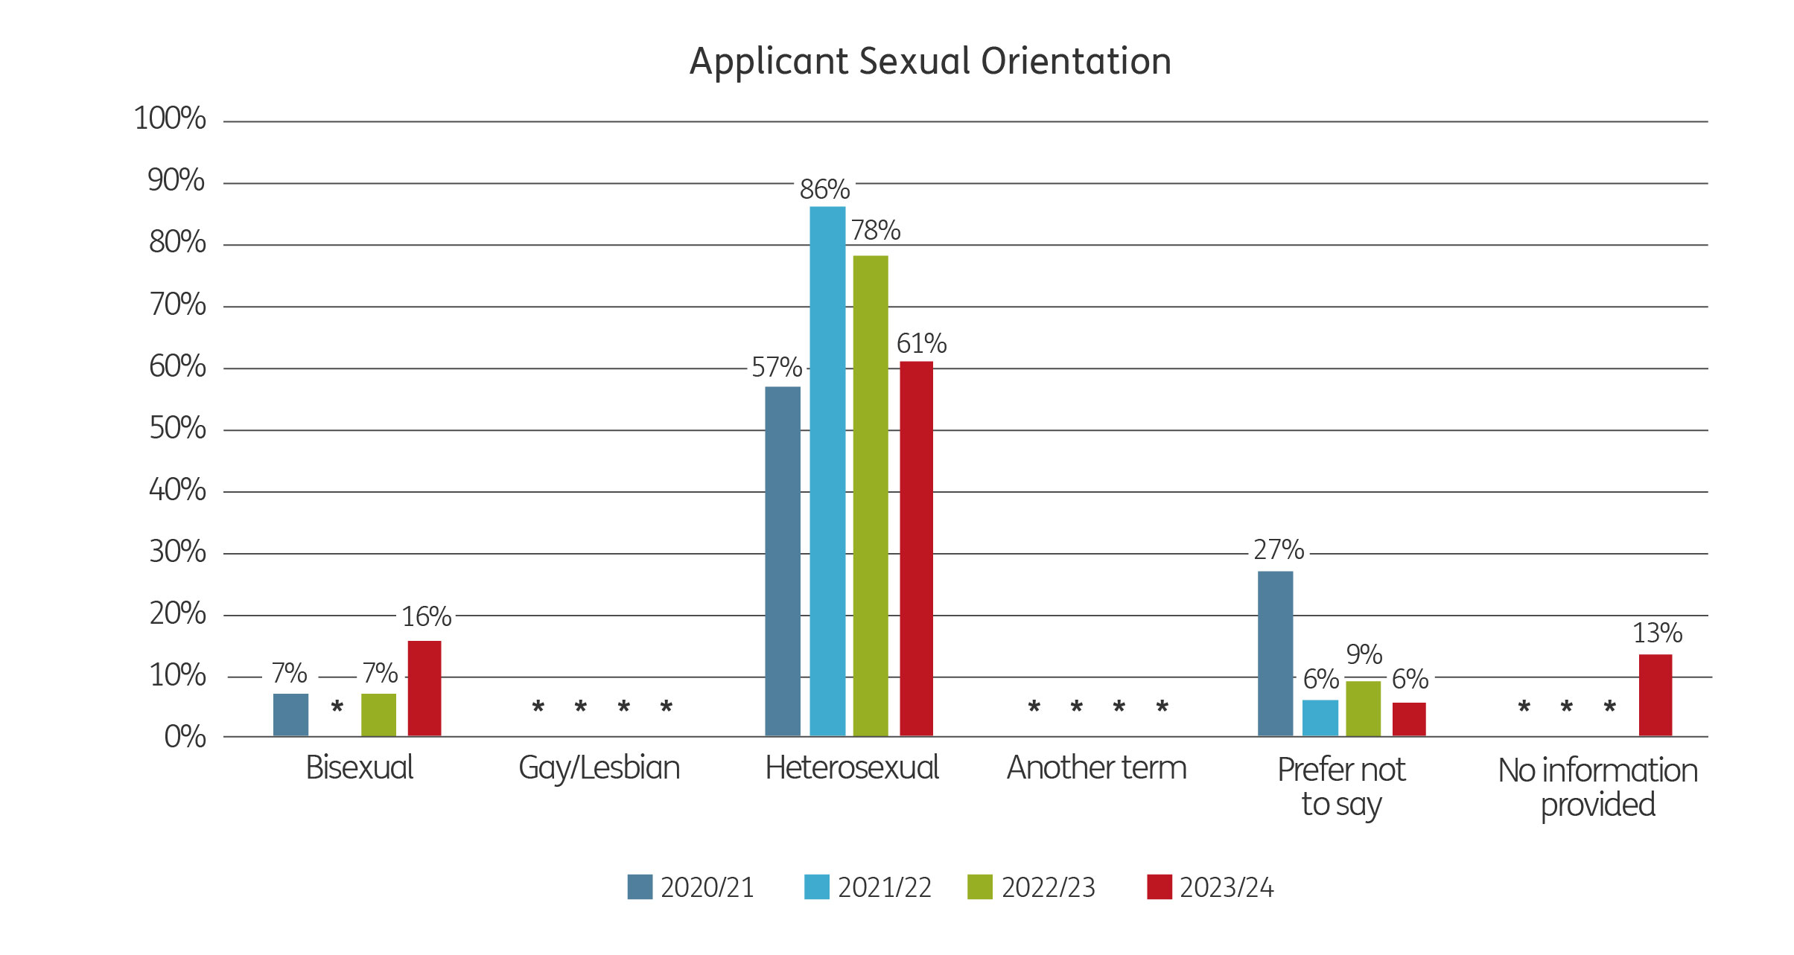
Most staff and applicants identify as heterosexual/straight. A higher percentage of staff (73%) than applicants (61%) identify as heterosexual/straight. Whereas last year, a higher percentage of applicants (78%) than staff (73%) identified as heterosexual/straight.
The number of heterosexual employees and applicants is over 20% lower than the percentage of 16-74-year-olds in Wales which is at 89.8%.
2021 Census Data: Sexual orientation | Wales
Filter by age 16 - 74 | number | %
Straight/Heterosexual | 2,027,196 | 89.84%
Lesbian, Gay, Bisexual or Other | 76,016 | 3.37%
Not answered | 153,136 | 6.79%
We advertise the Arts Council in Fyne Times Magazine (a magazine celebrating LGBTQ+ individuals). We’re also a Stonewall Champion and work closely with Stonewall, with the aim of being a more inclusive employer and attracting a diverse applicant pool.

National identity
The graphs below show the national identity of employees and applicants during this, and the three previous, financial years.

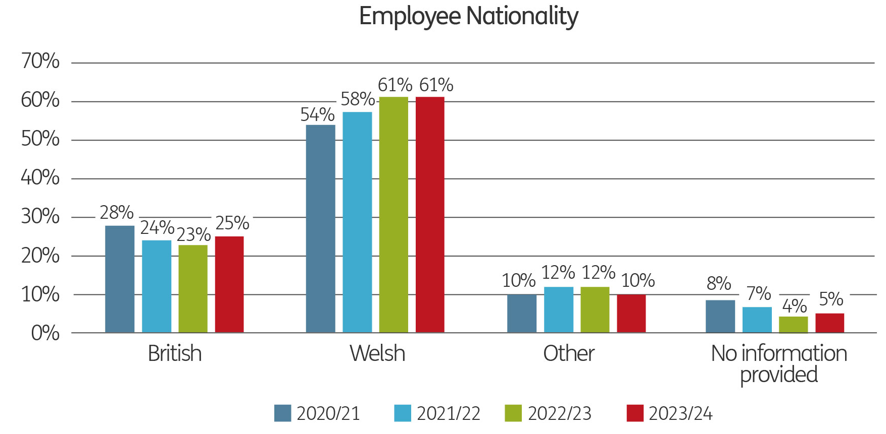
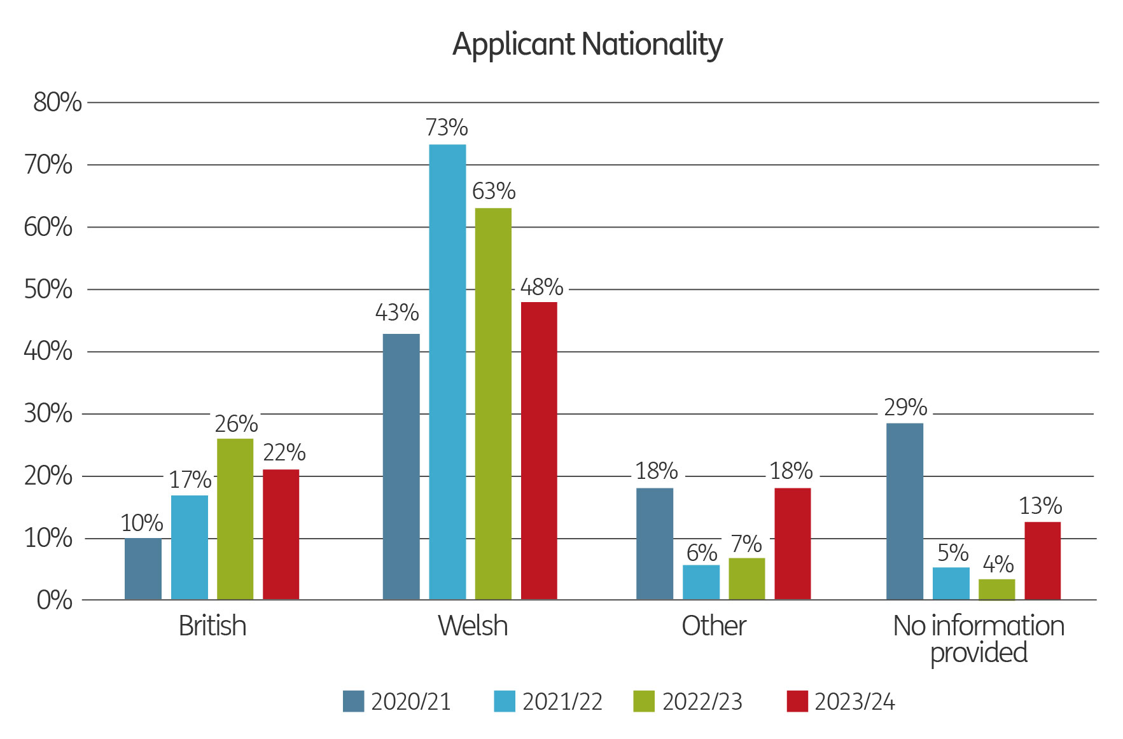
Most staff (61%) and applicants (48%) identify as Welsh, with British being the second highest percentage (25% of staff and 22% of applicants). Rather than supressing all the other nationalities they have been combined into ‘other’.
2021 Census Data: National Identity | Wales
Filter by age 16+ | number | %
British only identity | 574330 | 18.5%
Welsh only identity | 1715974 | 55.2%
Welsh and British only identity | 250646 | 8.1%
English only identity | 283291 | 9.1%
English and British only identity | 55135 | 1.8%
Any other combination of only UK identities | 59750 | 1.9%
Non-UK identity only | 131812 | 4.2%
UK identity and non-UK identity | 36561 | 1.2%

Religion
The graphs below show the religion of employees and applicants during this, and the three previous, financial years.
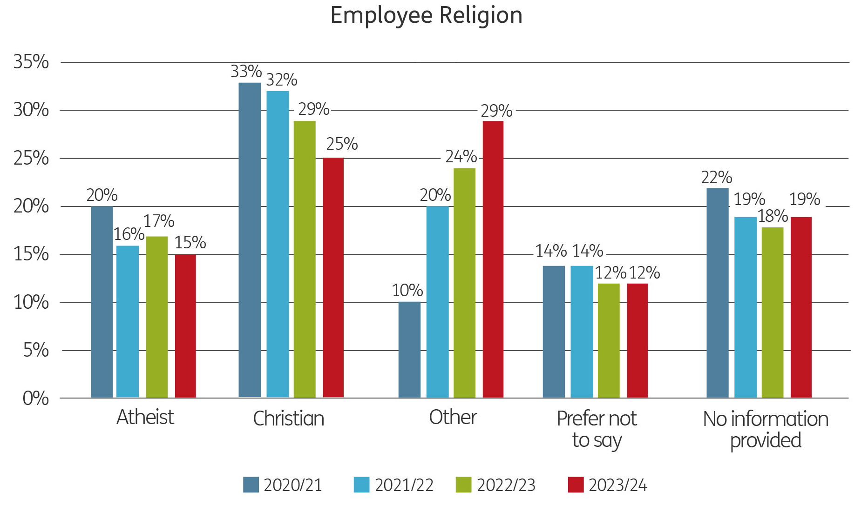
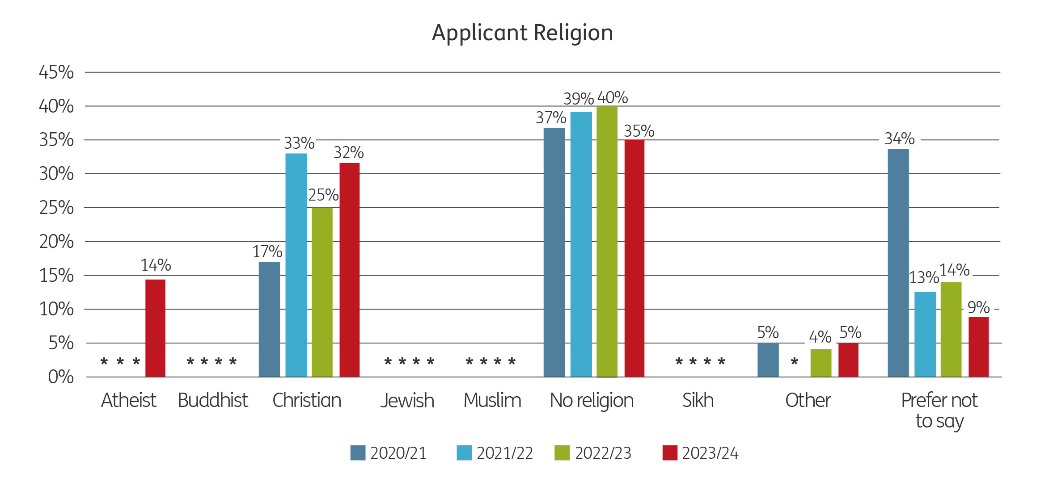

Over the last 4 financial years the majority of applicants (between 35% and 40%) have recorded that they have no religion. The number of employees who have recorded this option has been suppressed and not included on the above graph. Most staff have recorded their religion as Other (29%), closely followed by Christian (25%) with this being the second highest percentage for applicants (32%). The number of staff identifying as Christian has decreased year on year while ‘Other’ religions have increased slightly year on year.
Other religions have been selected by both staff and applicants, but that data has been suppressed.
The table below shows the 2021 Census results in relation to religion for people aged between 16 and 74.

2021 Census Data: Religion | Wales
Filter by age 16 - 74 | number | %
No religion | 1,076,454 | 47.7%
Christian | 962,639 | 42.7%
Buddhist | 8,901 | 0.4%
Hindu | 9,460 | 0.4%
Jewish | 1,610 | 0.1%
Muslim | 44,934 | 2.0%
Sikh | 3,066 | 0.1%
Other religion | 14,408 | 0.6%
Not answered | 134,872 | 6.0%
The percentage of the general population of Wales that recorded their religion as Christian (42.7%, down from the 57.6% recorded in the 2011 census) is higher than that of staff (25%) and applicants (32%). Despite the difference becoming smaller between the number of general public in Wales recording they have no religion and those of applicants is still significant at 47.7% and 35% respectively.
We don’t generally specify religion when taking positive action in recruitment campaigns.

Ethnicity
87.5% of staff have recorded their ethnicity as either White, White Asian, White British, White English, White Irish, White Other and White Welsh, and a combined 3.85% of staff identify as various other ethnicities.
93.1% of applicants have identified as White British, White Welsh or White Irish, with a further 7% of applicants identifying as various other ethnicities combined.

Disability
We ask staff to record whether they are disabled as per the medical/legal model and social model. Whilst the number of staff recording this information has slightly increased since last year (59% of staff have now recorded a response to the legal definition compared with 56% last year, 54% in 2021/22 and only 38% in 2020/21), there is still work to be done if we want to get an accurate picture of the composition of our staff. There isn’t currently a ‘prefer not to say’ option due to the setup of our HR system, and perhaps if this is included, we will see more staff responding by selecting that option.
The graphs below show the percentage of staff and applicants who identify as disabled according to both the medical/legal definition and social model of disability.
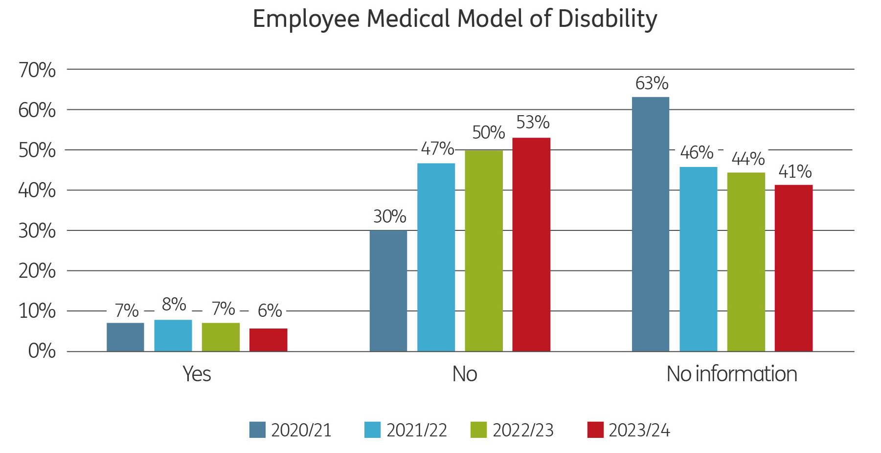
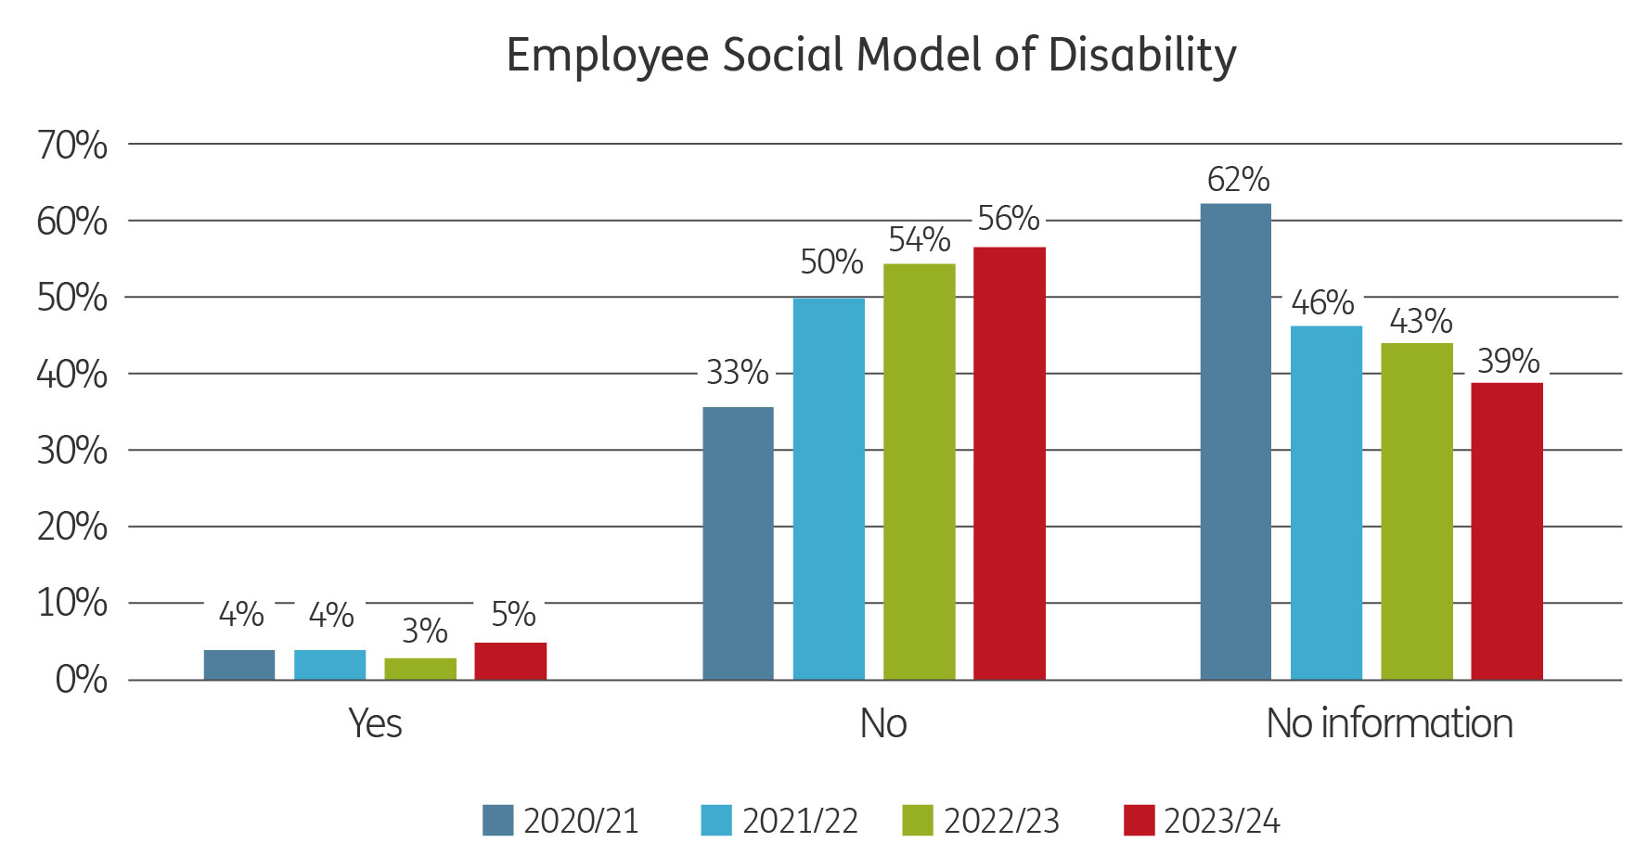

In previous years, half the number of staff who are disabled under the medical/legal model also consider themselves disabled under the social model. In the last year, nearly all staff who are disabled under the medical/legal model also consider themselves disabled under the social model.
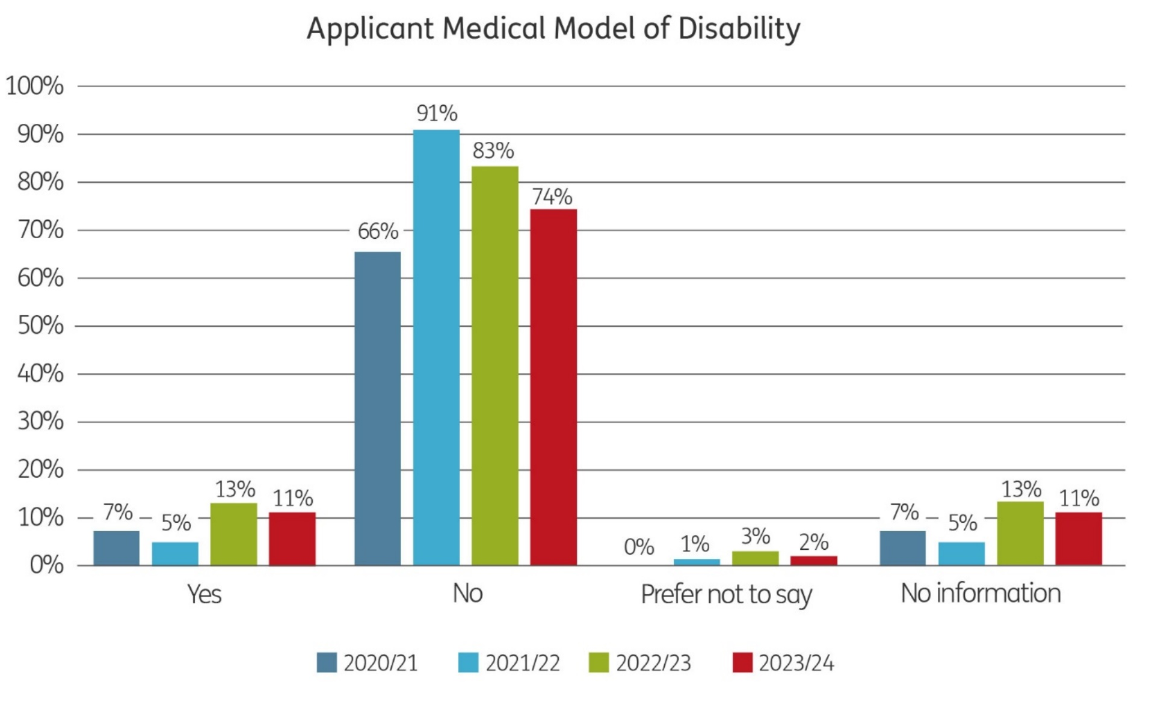
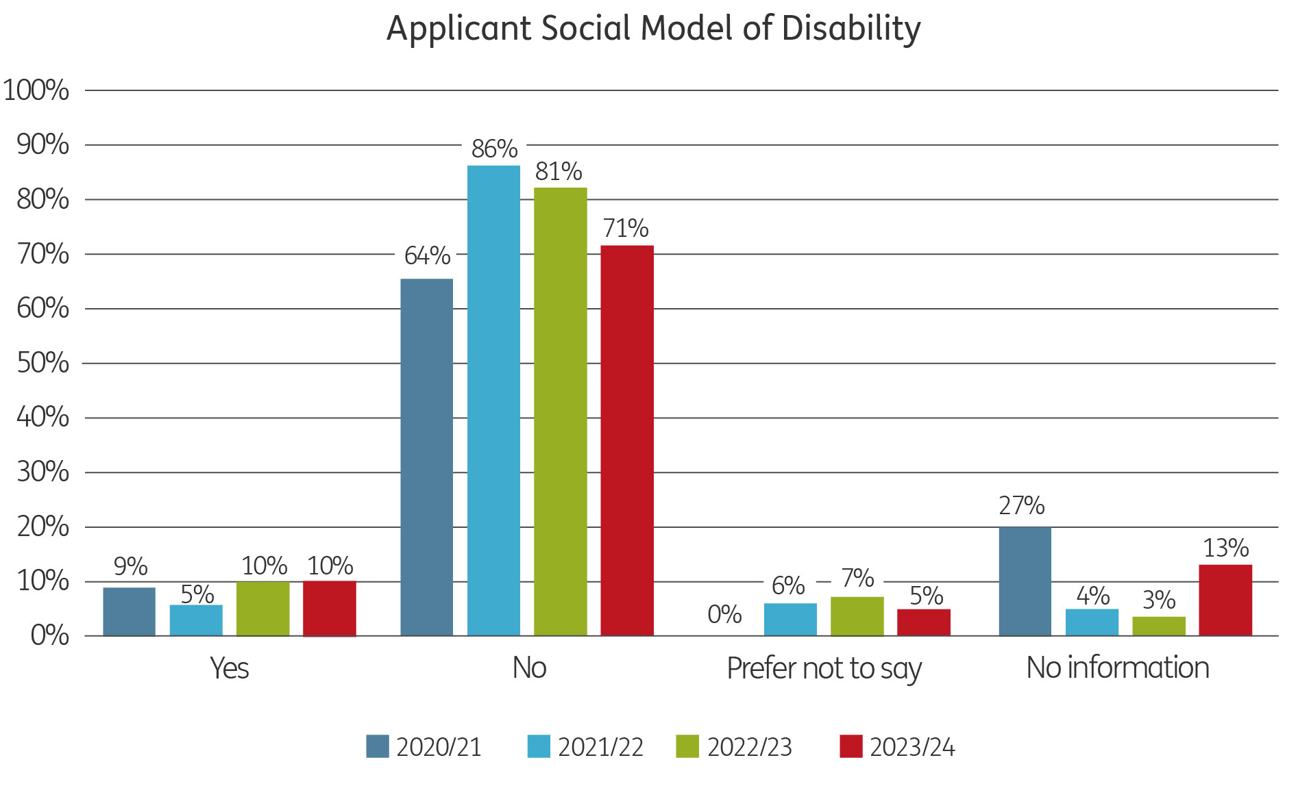The number of applicants who consider themselves to be disabled both according to the medical and social models of disability have stayed at roughly the same % as the last financial year.
It is difficult to make a comparison between staff and applicants because such a large number of staff have not responded to the questions.
Due to the definitions used in the census, it’s not possible to make a direct comparison, however, the census results have been filtered to show the most similar results and according to working age.

2021 Census Data: Disability | Wales
Filter by age 15*-74 | number | %
Disabled under the Equality Act | 956,422 | 21.3%
Disabled under the Equality Act: Day-to-day activities limited a lot | 430,298 | 9.6%
Disabled under the Equality Act: Day-to-day activities limited a little | 526,124 | 11.7%
Not disabled under the Equality Act | 354,3410 | 78.7%
*Due to the way the census data had been reported, the working age categories available for disability was 15-74.
Job adverts and the application form were updated in 2023 to include a section on the Disability Confident Scheme, specifying that the Arts Council is a Disability Confident Employer, whereby all disabled applicants who meet the essential criteria set out in the person specification are guaranteed an interview.

Age
The charts below show the age of employees at 31 March for the last three years, and the age of applicants at the point of application during the financial year.

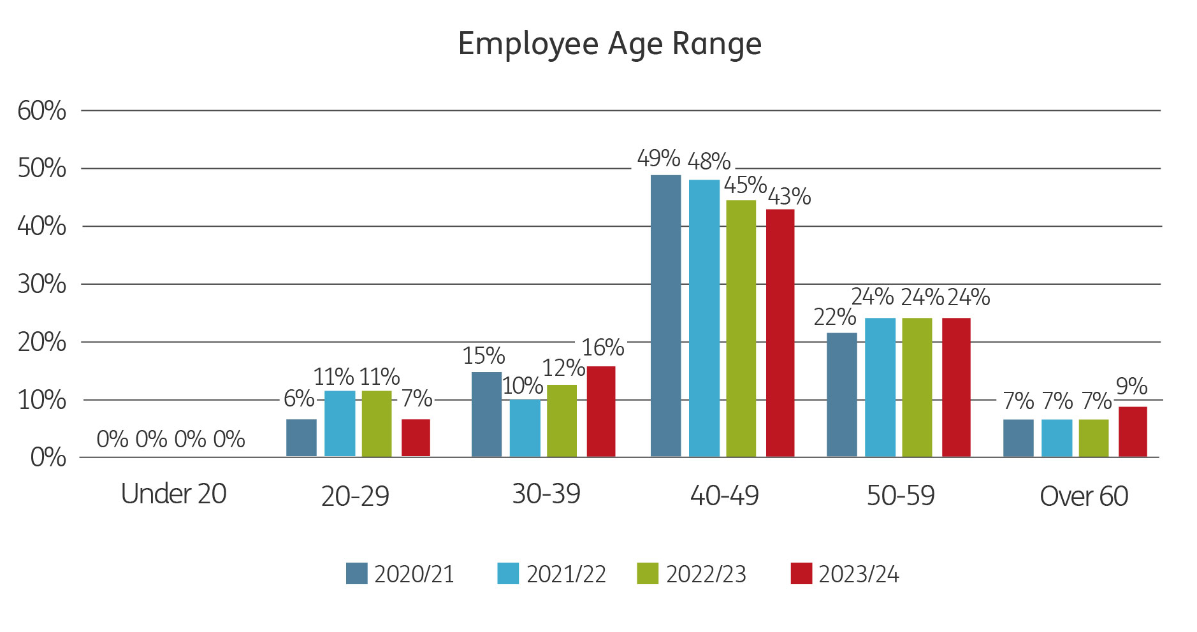

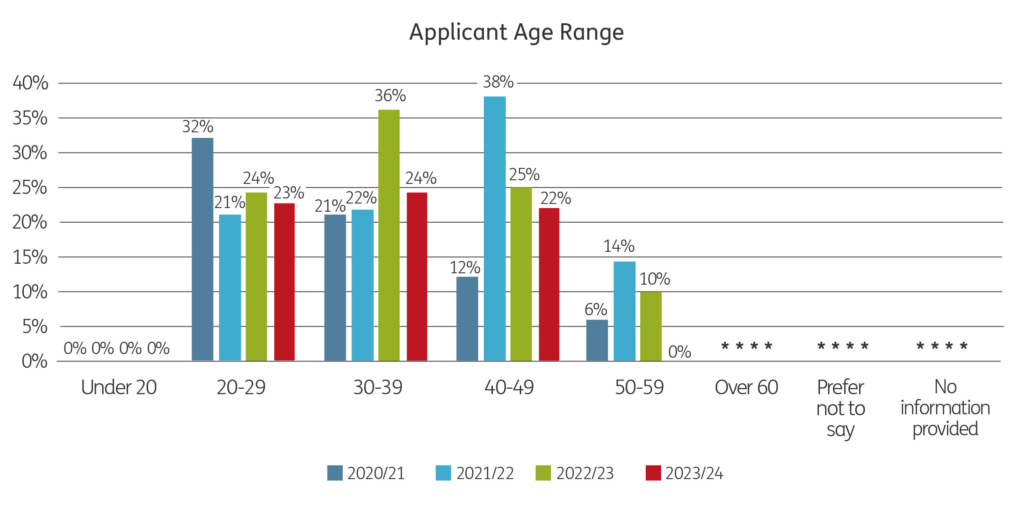

In 2023/24 most staff were aged between 40-49, whereas this age group saw a significant dip among applicants, dropping from 38% in 2021/22 to 25% in 2022/23, to 22% in 2023/24. Only 23% of staff were aged under 40, compared with 47% of applicants. There were no staff and no applicants ages under 20. Employee percentages for 50-59 and over 60 have slightly increased.

Equal Pay
The table below shows the number of female and male full-time equivalents (FTE) at each salary grade as at 31 March 2024. The table also shows the average salary at each grade per FTE and the difference between the average salaries of females and males at each grade.

Grade | Female (FTE) | Male (FTE) | Total (FTE) | Female avg. salary | Male avg. salary | % Difference
A | 0 | 0 | 0 | 0 | 0 | 0
B | 14.1 | 2 | 16.1 | £21,441.93 | £27,988 | -30.53%
C | 9.1 | 3 | 12.1 | £29,118.88 | £33,781 | -16.01%
D | 21.3 | 13.4 | 34.7 | £39,872.64 | £43,305.04 | -7.93%
E | 8 | 5 | 13 | £55,175 | £56,549 | -2.43%
F | 3 | 2 | 5 | £78,730.33 | £74,881 | 5.14%
CEO | 0 | 1 | 1 | 0 | £101,830 | 0.00%
This data does not include the one role which is funded by another organisation.
The average salary has been calculated by totalling the sum of all salaries for the females in a pay band, and then dividing by the female FTE figures (not the headcount). The average salary for males has been calculated using the same method.
Generally all staff are appointed at the lowest point of a grade, regardless of gender, and would be awarded an increment annually in August, subject to successful completion of their probationary period and satisfactory performance (as determined during the annual appraisal process).
Caution needs to be taken when reading the % Difference figures due to the significantly lower numbers of part-time male employees compared with the number of part-time female employees. The large majority of our male employees at grades B-E have been employed by the Arts Council for a number of years and have therefore reached their grade maxima. Where new employees have been recruited, they have, for the most part, joined at the grade minima. The majority of our new employees during 2023-24 were female, which has widened the gap in average salaries between male and female employees. With annual increments awarded in August each year, the margins will close as more females reach the top of their salary grade.
Council Members are appointed by Welsh Government via a public appointment process and in collaboration with the Public Bodies Unit and our Chair of Council who is involved in the shortlisting and interviews. We wouldn’t have any equalities monitoring data for Members or any candidates that may have applied and were not successful, as this would have been captured by the PBU and Welsh Government at the point of application and – for transparency – held separately and outside of the shortlisting and interview stages. It would not have been shared with the panel members.
The other consideration is that, given the relatively small number of Council Members we have, it’s likely that most of the data would need to be supressed under observed reporting thresholds.

Strategic Equality Committee
Meetings of our committee were cancelled in this year for a number of unavoidable reasons. However, the Chair of the Committee continued to monitor progress against the objectives, on behalf of Council throughout the year. Council also received a detailed and comprehensive presentation and accompanying report on the progress of our Widneing Engagement Action Plan.

Meeting our Legislative Responsibilities
During 2023/24 we monitored our progress with the day to day tasks required to meet our obligations under the Public Sector Equality Duty at two meetings of the monitoring group.

Our plan continues to address the general duty in relation to:
    - Eliminating unlawful discrimination, harassment and victimisation and other conduct that is prohibited by the Act
    - Advancing equality of opportunity between people who share a relevant protected characteristic and those who do not
    - Fostering good relations between people who share a protected characteristic and those who do not.
In relation to the specific duties for Wales, we have:
    - Continued to monitor and report on pay differences with specific reference to gender pay gaps.
    - Collate and monitor employment data, including applications for posts within the Arts Council but we are still to progress our work around monitoring of training and professional development amongst our staff. This will need to be taken forward in the next financial year.
    - We have continued to produce detailed equality impact assessments for all policies, programmes and projects.
    - We include equalities expectations in our procurement policy and processes but have not yet developed a process for monitoring progress against these expectations. This will need to be taken forward in the next financial year.

Evidence of the 5 Ways of Working

The integration of our work with the work of other public bodies
We continued to work in partnership with Amgueddfa Cymru on the delivery of our Widening Engagement Action Plan and conversations continued during the year with other public bodies around recruitment. The partnership with the network of 11 public bodies on our shared equality objectives continued although with all bodies facing difficult financial challenges questions were being asked about its future.

Increasing the number of collaborations and partnerships we are involved in
Strong collaborations and partnerships continue to be critical to our work and during the year we have continued to nurture the strategic level partnerships we have established. These have included those referenced below. We have continued to work closely with other Arts Councils across the UK learning from their work and sharing our own. This resulted in significant progress being made on the development of a UK wide access card scheme. A key partnership has been with Amgueddfa Cymru on taking forward our Widening Engagement Action Plan. We continued working with key equality bodies to help drive our work forward. These include Stonewall Cymru, Diverse Cymru, Chwarae Teg, Older People’s Commissioners Office, Race Council Cymru, Health Boards, Public Health Wales.

Listening to our staff, stakeholders and beneficiaries
Consulting with wider stakeholders, specifically organisations and individuals we don’t already have an ongoing relationship with continues to be a key aim and ongoing challenge for us. Our Widening Engagement work has continued to be key in informing the future direction of our plan

Preventing Harm
Our equalities objectives have been designed to address the prevention agenda.

Thinking Long Term
This continues to be a key driver for our work. Considering the longer term impact of what we do now has become more embedded in our planning.

